Chp 1 Quadratics Exam Qs
1a. [1 mark]
Write down the equation of the axis of symmetry.

Markscheme
(must be an equation) A1 N1
[1 mark]
1b. [2 marks]
The function f can be written in the form 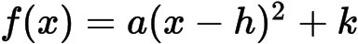 .
Write down the value of h and of k .

Markscheme
, A1A1 N2
[2 marks]
1c. [3 marks]
The function f can be written in the form 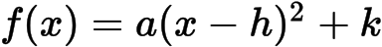 .
Find a .

Markscheme
attempt to substitute coordinates of any point on the graph into f (M1)
e.g. 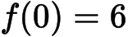 , 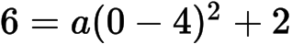 , 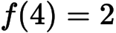
correct equation (do not accept an equation that results from ) (A1)
e.g. 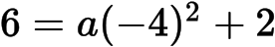 , 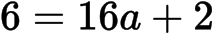
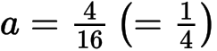A1 N2
[3 marks]
2a. [2 marks]
Write down 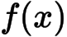 in the form .

Markscheme
A1A1 N2
[2 marks]
2b. [4 marks]
Find another expression for in the form 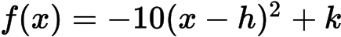 .

Markscheme
METHOD 1
attempting to find the x-coordinate of maximum point (M1)
e.g. averaging the x-intercepts, sketch, 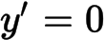 , axis of symmetry
attempting to find the y-coordinate of maximum point (M1)
e.g. 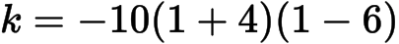
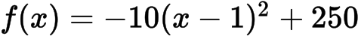A1A1 N4
METHOD 2
attempt to expand (M1)
e.g. 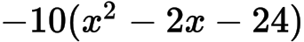
attempt to complete the square (M1)
e.g. 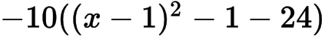
A1A1 N4
[4 marks]
2c. [2 marks]
Show that can also be written in the form 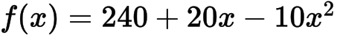 .

Markscheme
attempt to simplify (M1)
e.g. distributive property, 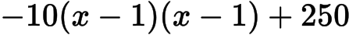
correct simplification A1
e.g. 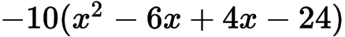 , 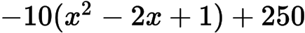
AG N0
[2 marks]
2d. [7 marks]
A particle moves along a straight line so that its velocity, 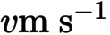 , at time t seconds is given by 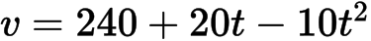 , for 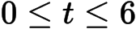 .
(i) Find the value of t when the speed of the particle is greatest.
(ii) Find the acceleration of the particle when its speed is zero.

Markscheme
(i) valid approach (M1)
e.g. vertex of parabola, 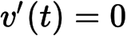
A1 N2
(ii) recognizing 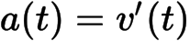(M1)
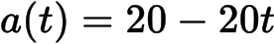A1A1
speed is zero 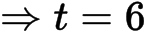(A1)
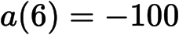 (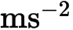) A1 N3
[7 marks]
3a. [3 marks]
Express in the form 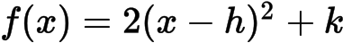 .

Markscheme
evidence of obtaining the vertex (M1)
e.g. a graph, 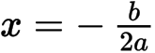 , completing the square
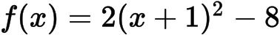A2 N3
[3 marks]
3b. [1 mark]
Write down the equation of the axis of symmetry of the graph of f .

Markscheme
(equation must be seen) A1 N1
[1 mark]
3c. [2 marks]
Express in the form 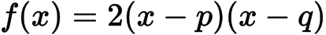 .

Markscheme
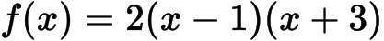A1A1 N2
[2 marks]
4a. [2 marks]
Show that 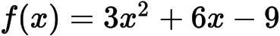 .

Markscheme
A1
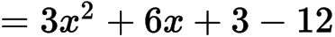A1
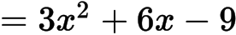AG N0
[2 marks]
4b. [8 marks]
For the graph of f
(i) write down the coordinates of the vertex;
(ii) write down the equation of the axis of symmetry;
(iii) write down the y-intercept;
(iv) find both x-intercepts.

Markscheme
(i) vertex is A1A1 N2
(ii) (must be an equation) A1 N1
(iii) A1 N1
(iv) evidence of solving 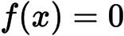(M1)
e.g. factorizing, formula,
correct working A1
e.g. 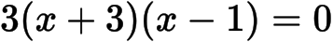 , 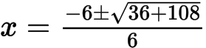
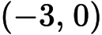, 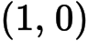A1A1 N1N1
[8 marks]
4c. [2 marks]
Hence sketch the graph of f .

Markscheme
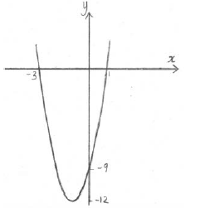 A1A1 N2
Note: Award A1 for a parabola opening upward, A1 for vertex and intercepts in approximately correct positions.
[2 marks]
4d. [3 marks]
Let 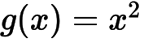 . The graph of f may be obtained from the graph of g by the two transformations:
a stretch of scale factor t in the y-direction
followed by a translation of 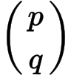 .
Find and the value of t.

Markscheme
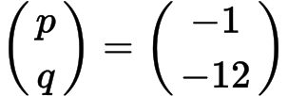 , (accept 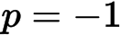 , 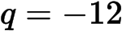 , ) A1A1A1 N3
[3 marks]
5a. [4 marks]
Find both x-intercepts.

Markscheme
evidence of attempting to solve (M1)
evidence of correct working A1
e.g. 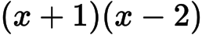 , 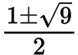
intercepts are 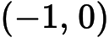 and 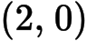 (accept , ) A1A1 N1N1
[4 marks]
5b. [2 marks]
Find the x-coordinate of the vertex.

Markscheme
evidence of appropriate method (M1)
e.g. 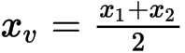 , 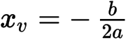 , reference to symmetry
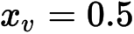A1 N2
[2 marks]
6a. [4 marks]
Find the x-intercepts of the graph.

Markscheme
evidence of setting function to zero (M1)
e.g. , 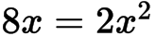
evidence of correct working A1
e.g. 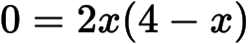 , 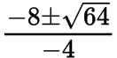
x-intercepts are at 4 and 0 (accept (4, 0) and (0, 0) , or , ) A1A1 N1N1
[4 marks]
6b. [3 marks]
(i) Write down the equation of the axis of symmetry.
(ii) Find the y-coordinate of the vertex.

Markscheme
(i) (must be equation) A1 N1
(ii) substituting into (M1)
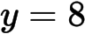A1 N2
[3 marks]
7a. [2 marks]
Show that .

Markscheme
A1
A1
AG N0
[2 marks]
7b. [7 marks]
For the graph of f
(i) write down the coordinates of the vertex;
(ii) write down the y-intercept;
(iii) find both x-intercepts.

Markscheme
(i) vertex is 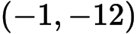A1A1 N2
(ii) 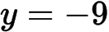 , or 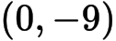A1 N1
(iii) evidence of solving M1
e.g. factorizing, formula
correct working A1
e.g. ,
, , or 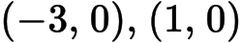A1A1 N2
[7 marks]
7c. [3 marks]
Hence sketch the graph of f .

Markscheme
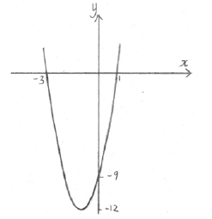 A1A1A1 N3
Note: Award A1 for a parabola opening upward, A1 for vertex in approximately correct position, A1 for intercepts in approximately correct positions. Scale and labelling not required.
[3 marks]
7d. [3 marks]
Let . The graph of f may be obtained from the graph of g by the following two transformations
a stretch of scale factor t in the y-direction,
followed by a translation of 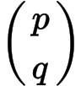 .
Write down and the value of t .

Markscheme
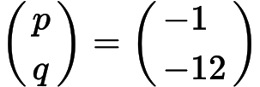 , A1A1A1 N3
[3 marks]
8. [6 marks]
The equation 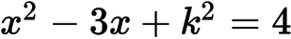 has two distinct real roots. Find the possible values of k .

Markscheme
evidence of rearranged quadratic equation (may be seen in working) A1
e.g. 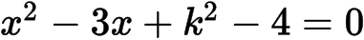 ,
evidence of discriminant (must be seen explicitly, not in quadratic formula) (M1)
e.g. 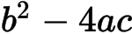 , 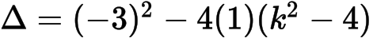
recognizing that discriminant is greater than zero (seen anywhere, including answer) R1
e.g. 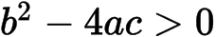 , 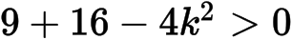
correct working (accept equality) A1
e.g. 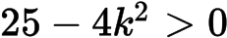 , 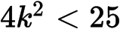 , 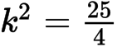
both correct values (even if inequality never seen) (A1)
e.g. 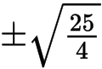 , 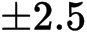
correct interval A1 N3
e.g. 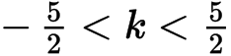 , 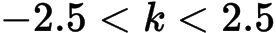
Note: Do not award the final mark for unfinished values, or for incorrect or reversed inequalities, including 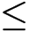 , , .
Special cases:
If working shown, and candidates attempt to rearrange the quadratic equation to equal zero, but find an incorrect value of c, award A1M1R1A0A0A0.
If working shown, and candidates do not rearrange the quadratic equation to equal zero, but find 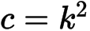 or , award A0M1R1A0A0A0.
[6 marks]
9a. [6 marks]
(a) Write down the -intercepts of the graph of .
(b) Find the coordinates of the vertex of the graph of .

Markscheme
(a) , (accept (, ), (, ) ) A1A1 N2
[2 marks]
(b) METHOD 1
attempt to find -coordinate (M1)
eg 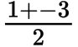 , 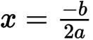 , 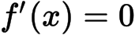
correct value, (may be seen as a coordinate in the answer) A1
attempt to find their -coordinate (M1)
eg 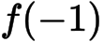 , , 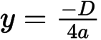
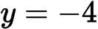A1
vertex (, ) N3
METHOD 2
attempt to complete the square (M1)
eg 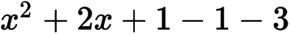
attempt to put into vertex form (M1)
eg 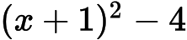 , 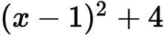
vertex (, ) A1A1 N3
[4 marks]
9b. [2 marks]
Write down the -intercepts of the graph of .

Markscheme
, (accept (, ), (, ) ) A1A1 N2
[2 marks]
9c. [4 marks]
Find the coordinates of the vertex of the graph of .

Markscheme
METHOD 1
attempt to find -coordinate (M1)
eg , ,
correct value, (may be seen as a coordinate in the answer) A1
attempt to find their -coordinate (M1)
eg , ,
A1
vertex (, ) N3
METHOD 2
attempt to complete the square (M1)
eg
attempt to put into vertex form (M1)
eg ,
vertex (, ) A1A1 N3
[4 marks]
10. [8 marks]
The equation 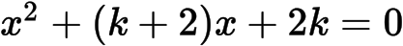 has two distinct real roots.
Find the possible values of .

Markscheme
evidence of discriminant (M1)
eg 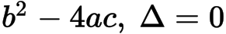
correct substitution into discriminant (A1)
eg
correct discriminant A1
eg 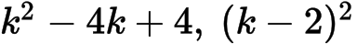
recognizing discriminant is positive R1
eg
attempt to solve their quadratic in (M1)
eg factorizing, 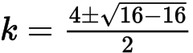
correct working A1
eg 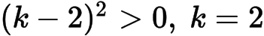, sketch of positive parabola on the x-axis
correct values A2 N4
eg
[8 marks]
11a. [4 marks]
(i) Write down the coordinates of the vertex.
(ii) Hence or otherwise, express the function in the form .

Markscheme
(i) or , 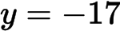A1A1 N2
(ii) evidence of valid approach (M1)
e.g. graph, completing the square, equating coefficients
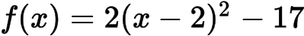A1 N2
[4 marks]
11b. [3 marks]
Solve the equation .

Markscheme
evidence of valid approach (M1)
e.g. graph, quadratic formula
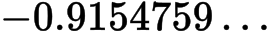 , 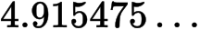
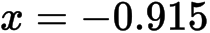 , 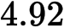A1A1 N3
[3 marks]
12a. [2 marks]
Write down the value of q and of r.

Markscheme
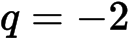 , or 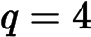 , A1A1 N2
[2 marks]
12b. [1 mark]
Write down the equation of the axis of symmetry.

Markscheme
(must be an equation) A1 N1
[1 mark]
12c. [3 marks]
Find the value of p.

Markscheme
substituting into the equation (M1)
e.g. 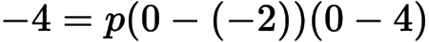 , 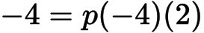
correct working towards solution (A1)
e.g. 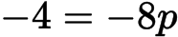
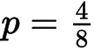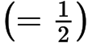A1 N2
[3 marks]
13a. [5 marks]
Find the value of k .

Markscheme
valid approach (M1)
e.g. , 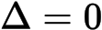 , 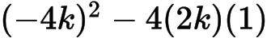
correct equation A1
e.g. 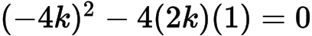 , 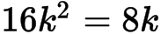 , 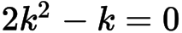
correct manipulation A1
e.g. 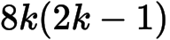 , 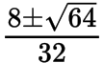
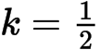A2 N3
[5 marks]
13b. [2 marks]
The line intersects the graph of f . Find all possible values of p .

Markscheme
recognizing vertex is on the x-axis M1
e.g. (1, 0) , sketch of parabola opening upward from the x-axis
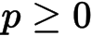A1 N1
[2 marks]

Printed for British School of Beijing
© International Baccalaureate Organization 2015
International Baccalaureate® - Baccalauréat International® - Bachillerato Internacional®

