Chp 20 IB SL Maths Qs ms
1a. [4 marks]
The weekly wages (in dollars) of 80 employees are displayed in the cumulative frequency curve below.
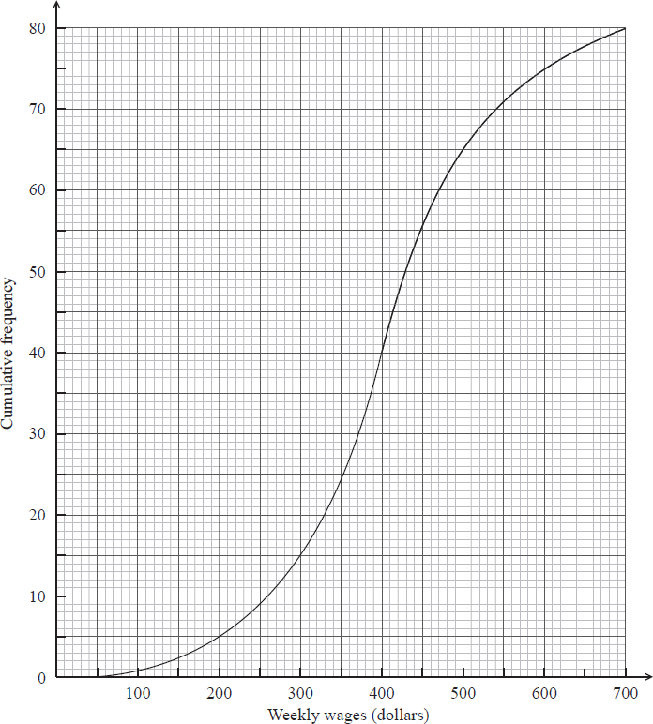
(i) Write down the median weekly wage.
(ii) Find the interquartile range of the weekly wages.
1b. [3 marks]
The box-and-whisker plot below displays the weekly wages of the employees.
Write down the value of
(i) ;
(ii) ;
(iii) .
1c. [3 marks]
Employees are paid per hour.
Find the median number of hours worked per week.
1d. [5 marks]
Employees are paid per hour.
Find the number of employees who work more than 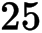 hours per week.
2a. [2 marks]
The cumulative frequency curve below represents the marks obtained by 100 students.
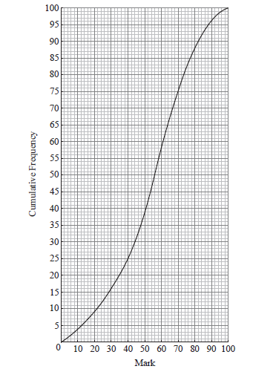
Find the median mark.
2b. [3 marks]
Find the interquartile range.
3a. [2 marks]
The ages of people attending a music concert are given in the table below.
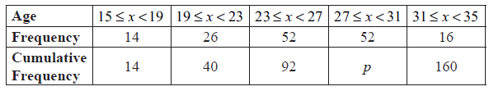
Find p .
3b. [5 marks]
The cumulative frequency diagram is given below.
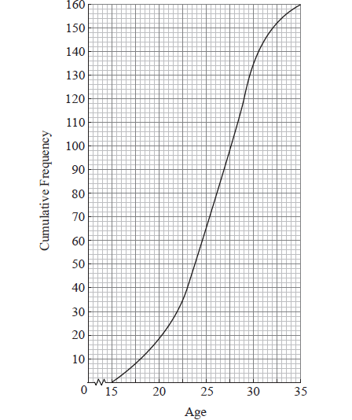
Use the diagram to estimate
(i) the 80th percentile;
(ii) the interquartile range.
4a. [3 marks]
The histogram below shows the time T seconds taken by 93 children to solve a puzzle.
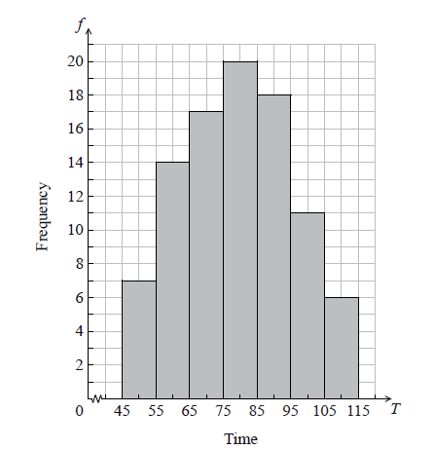
The following is the frequency distribution for T .
(i) Write down the value of p and of q .
(ii) Write down the median class.
4b. [2 marks]
A child is selected at random. Find the probability that the child takes less than 95 seconds to solve the puzzle.
4c. [2 marks]
Consider the class interval 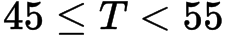 .
(i) Write down the interval width.
(ii) Write down the mid-interval value.
4d. [4 marks]
Hence find an estimate for the
(i) mean;
(ii) standard deviation.
4e. [2 marks]
John assumes that T is normally distributed and uses this to estimate the probability that a child takes less than 95 seconds to solve the puzzle.
Find John’s estimate.
5a. [1 mark]
The cumulative frequency curve below represents the heights of 200 sixteen-year-old boys.
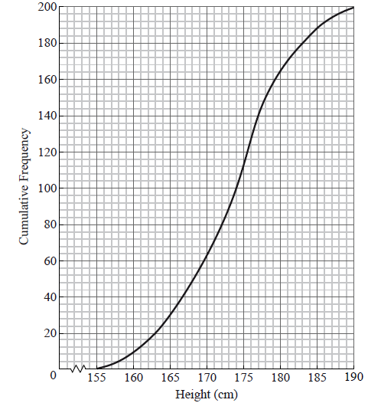
Use the graph to answer the following.
Write down the median value.
5b. [2 marks]
A boy is chosen at random. Find the probability that he is shorter than .
5c. [3 marks]
Given that 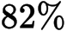 of the boys are taller than 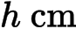, find h .
6a. [2 marks]
Consider the following cumulative frequency table.
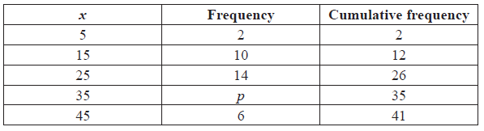
Find the value of .
6b. [4 marks]
Find
(i) the mean;
(ii) the variance.
7. [7 marks]
A random variable is normally distributed with 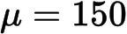 and .
Find the interquartile range of .
8a. [4 marks]
A running club organizes a race to select girls to represent the club in a competition.
The times taken by the group of girls to complete the race are shown in the table below.
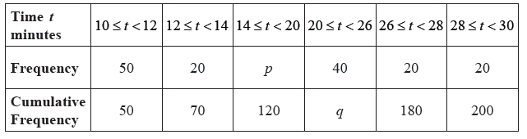
Find the value of and of .
8b. [3 marks]
A girl is chosen at random.
(i) Find the probability that the time she takes is less than minutes.
(ii) Find the probability that the time she takes is at least 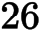 minutes.
8c. [4 marks]
A girl is selected for the competition if she takes less than minutes to complete the race.
Given that of the girls are not selected,
(i) find the number of girls who are not selected;
(ii) find .
8d. [4 marks]
Girls who are not selected, but took less than 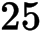 minutes to complete the race, are allowed another chance to be selected. The new times taken by these girls are shown in the cumulative frequency diagram below.
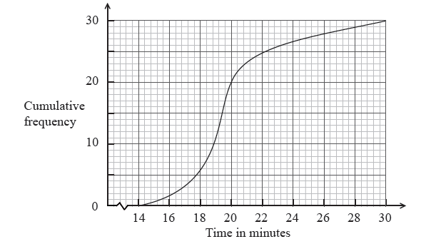
(i) Write down the number of girls who were allowed another chance.
(ii) Find the percentage of the whole group who were selected.
9a. [1 mark]
The weights in grams of 80 rats are shown in the following cumulative frequency diagram.
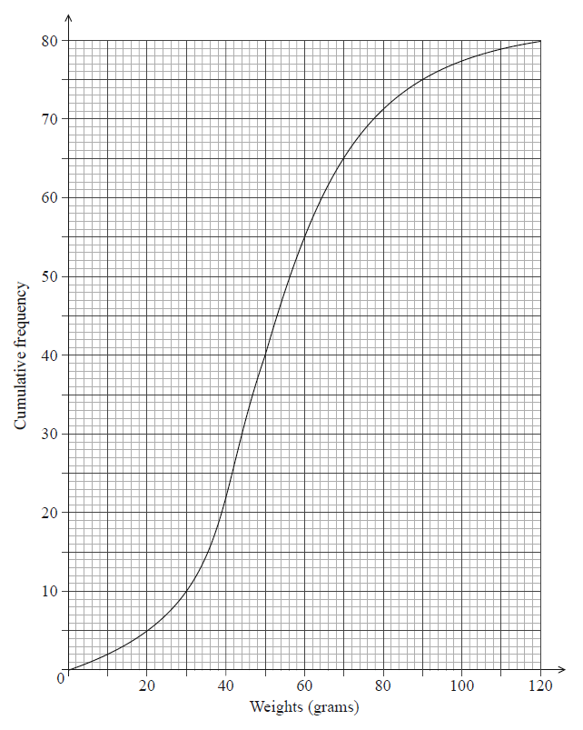
Do NOT write solutions on this page.
Write down the median weight of the rats.
9b. [3 marks]
Find the percentage of rats that weigh 70 grams or less.
9c. [2 marks]
The same data is presented in the following table.
Weights  grams |  |  | 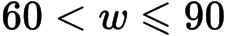
Frequency |  | 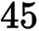

Write down the value of .
9d. [2 marks]
The same data is presented in the following table.
Weights
grams
Frequency

Find the value of .
9e. [3 marks]
The same data is presented in the following table.
Weights
grams
Frequency

Use the values from the table to estimate the mean and standard deviation of the weights.
9f. [2 marks]
Assume that the weights of these rats are normally distributed with the mean and standard deviation estimated in part (c).
Find the percentage of rats that weigh 70 grams or less.
9g. [3 marks]
Assume that the weights of these rats are normally distributed with the mean and standard deviation estimated in part (c).
A sample of five rats is chosen at random. Find the probability that at most three rats weigh 70 grams or less.
10a. [2 marks]
The following is a cumulative frequency diagram for the time t, in minutes, taken by 80 students to complete a task.
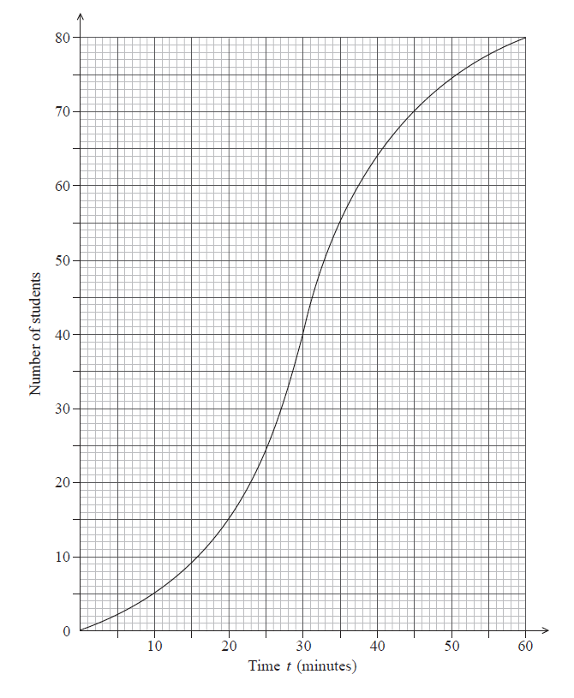
Find the number of students who completed the task in less than 45 minutes.
10b. [3 marks]
Find the number of students who took between 35 and 45 minutes to complete the task.
10c. [2 marks]
Given that 50 students take less than k minutes to complete the task, find the value of .
11a. [1 mark]
The following is a cumulative frequency diagram for the time t, in minutes, taken by 80 students to complete a task.
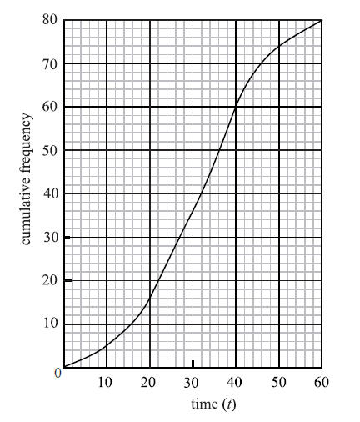
Write down the median.
11b. [3 marks]
Find the interquartile range.
11c. [2 marks]
Complete the frequency table below.
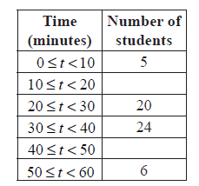
12a. [3 marks]
In a school with 125 girls, each student is tested to see how many sit-up exercises (sit-ups) she can do in one minute. The results are given in the table below.
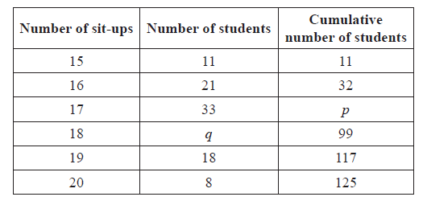
(i) Write down the value of p.
(ii) Find the value of q.
12b. [2 marks]
Find the median number of sit-ups.
12c. [2 marks]
Find the mean number of sit-ups.
13a. [2 marks]
A box contains 100 cards. Each card has a number between one and six written on it. The following table shows the frequencies for each number.
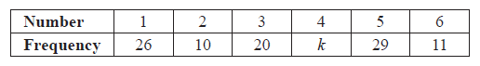
Calculate the value of k.
13b. [5 marks]
Find
(i) the median;
(ii) the interquartile range.
14a. [3 marks]
A fisherman catches 200 fish to sell. He measures the lengths, l cm of these fish, and the results are shown in the frequency table below.
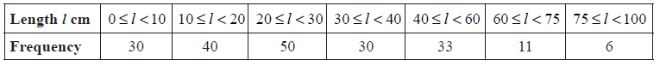
Calculate an estimate for the standard deviation of the lengths of the fish.
14b. [6 marks]
A cumulative frequency diagram is given below for the lengths of the fish.
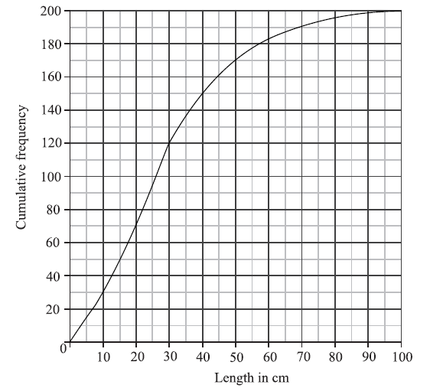
Use the graph to answer the following.
(i) Estimate the interquartile range.
(ii) Given that of the fish have a length more than 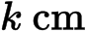, find the value of k.
14c. [2 marks]
In order to sell the fish, the fisherman classifies them as small, medium or large.
Small fish have a length less than .
Medium fish have a length greater than or equal to but less than .
Large fish have a length greater than or equal to .
Write down the probability that a fish is small.
14d. [2 marks]
The cost of a small fish is , a medium fish , and a large fish .
Copy and complete the following table, which gives a probability distribution for the cost .
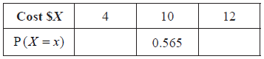
14e. [2 marks]
Find 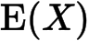 .
15a. [1 mark]
The following diagram is a box and whisker plot for a set of data.
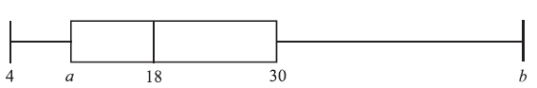
The interquartile range is 20 and the range is 40.
Write down the median value.
15b. [4 marks]
Find the value of
(i) ;
(ii) .
16a. [2 marks]
A standard die is rolled 36 times. The results are shown in the following table.
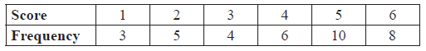
Write down the standard deviation.
16b. [1 mark]
Write down the median score.
16c. [3 marks]
Find the interquartile range.
17a. [4 marks]
The following frequency distribution of marks has mean 4.5.
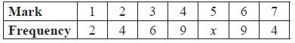
Find the value of x.
17b. [2 marks]
Write down the standard deviation.
18a. [4 marks]
The following table gives the examination grades for 120 students.
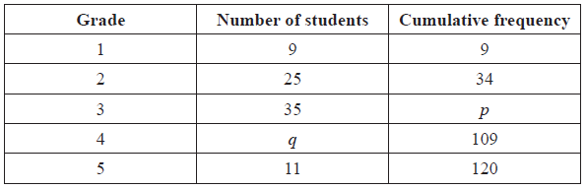
Find the value of
(i) p ;
(ii) q .
18b. [2 marks]
Find the mean grade.
18c. [1 mark]
Write down the standard deviation.
19a. [2 marks]
There are nine books on a shelf. For each book, x is the number of pages, and y is the selling price in pounds (£). Let r be the correlation coefficient.
Write down the possible minimum and maximum values of r .
19b. [1 mark]
Given that 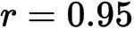 , which of the following diagrams best represents the data.
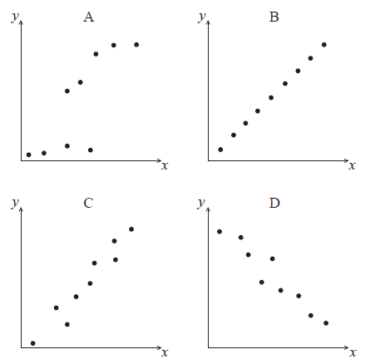
19c. [2 marks]
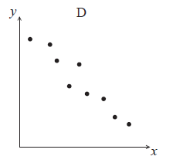
For the data in diagram D , which two of the following expressions describe the correlation between x and y ?
perfect, zero, linear, strong positive, strong negative, weak positive, weak negative
20a. [2 marks]
A data set has a mean of 20 and a standard deviation of 6.
Each value in the data set has 10 added to it. Write down the value of
(i) the new mean;
(ii) the new standard deviation.
20b. [3 marks]
Each value in the original data set is multiplied by 10.
(i) Write down the value of the new mean.
(ii) Find the value of the new variance.
21a. [3 marks]
A scientist has 100 female fish and 100 male fish. She measures their lengths to the nearest cm. These are shown in the following box and whisker diagrams.
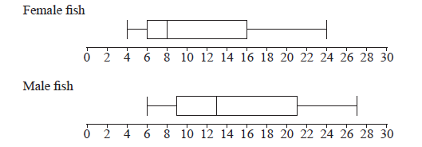
Find the range of the lengths of all 200 fish.
21b. [2 marks]
Four cumulative frequency graphs are shown below.
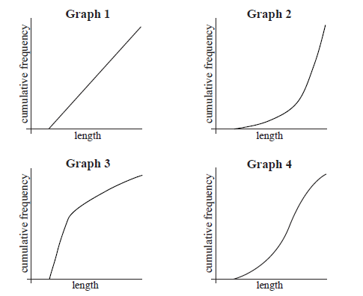
Which graph is the best representation of the lengths of the female fish?

Printed for British School of Beijing
© International Baccalaureate Organization 2015
International Baccalaureate® - Baccalauréat International® - Bachillerato Internacional®

Chp 20 IB SL Maths Qs ms
1a. [4 marks]
The weekly wages (in dollars) of 80 employees are displayed in the cumulative frequency curve below.
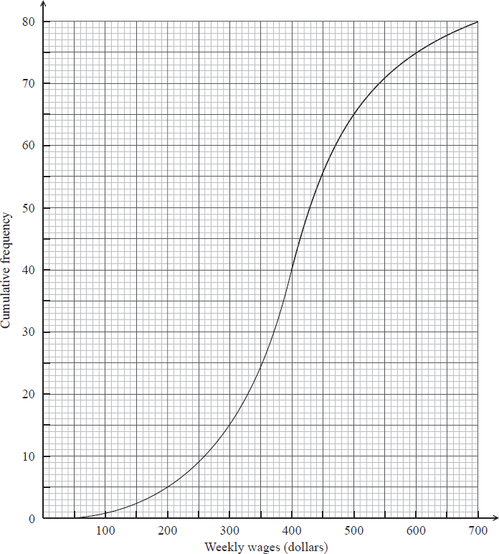

Markscheme
(i) median weekly wage (dollars) A1 N1
(ii) lower quartile , upper quartile 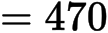(A1)(A1)
(dollars) (accept any notation suggesting interval 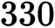 to 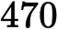) A1 N3
Note: Exception to the FT rule. Award A1(FT) for an incorrect IQR only if both quartiles are explicitly noted.
[4 marks]
1b. [3 marks]

Markscheme
(i) (dollars) A1 N1
(ii) (dollars) A1 N1
(iii) 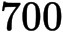 (dollars) A1 N1
[3 marks]
1c. [3 marks]

Markscheme
valid approach (M1)
e.g. 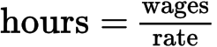
correct substitution (A1)
e.g. 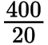
median hours per week 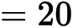 A1 N2
[3 marks]
1d. [5 marks]

Markscheme
attempt to find wages for 25 hours per week (M1)
e.g.
correct substitution (A1)
e.g. 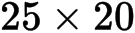
finding wages (A1)
65 people (earn 500) (A1)
15 people (work more than 25 hours) A1 N3
[5 marks]
2a. [2 marks]
The cumulative frequency curve below represents the marks obtained by 100 students.

Markscheme
evidence of median position (M1)
e.g. 50, line on sketch
median is 56 A1 N2
[2 marks]
2b. [3 marks]

Markscheme
lower quartile 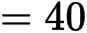 , upper quartile 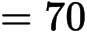 (A1)(A1)
interquartile range 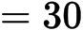A1 N3
[3 marks]
3a. [2 marks]
The ages of people attending a music concert are given in the table below.

Markscheme
evidence of valid approach (M1)
e.g. 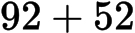 , line on graph at
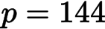A1 N2
[2 marks]
3b. [5 marks]

Markscheme
(i) evidence of valid approach (M1)
e.g. line on graph, 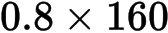 , using complement
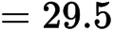A1 N2
(ii) 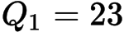 ; 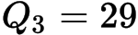 (A1)(A1)
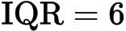 (accept any notation that suggests an interval) A1 N3
[5 marks]
4a. [3 marks]
The histogram below shows the time T seconds taken by 93 children to solve a puzzle.
The following is the frequency distribution for T .

Markscheme
(i) 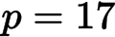 , 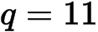A1A1 N2
(ii) 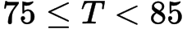A1 N1
[3 marks]
4b. [2 marks]

Markscheme
evidence of valid approach (M1)
e.g. adding frequencies
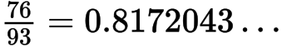
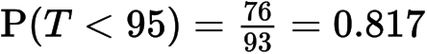A1 N2
[2 marks]
4c. [2 marks]

Markscheme
(i) 10 A1 N1
(ii) 50 A1 N1
[2 marks]
4d. [4 marks]

Markscheme
(i) evidence of approach using mid-interval values (may be seen in part (ii)) (M1)
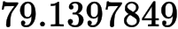
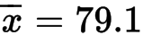A2 N3
(ii) 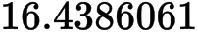
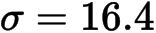A1 N1
[4 marks]
4e. [2 marks]

Markscheme
e.g. standardizing, 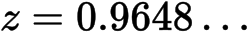
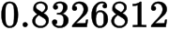
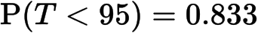A1 N2
[2 marks]
5a. [1 mark]
The cumulative frequency curve below represents the heights of 200 sixteen-year-old boys.
Use the graph to answer the following.

Markscheme
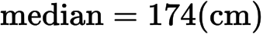A1 N1
[1 mark]
5b. [2 marks]

Markscheme
attempt to find number shorter than 161 (M1)
e.g. line on graph, 12 boys
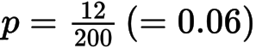A1 N2
[2 marks]
5c. [3 marks]

Markscheme
METHOD 1
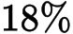 have a height less than h (A1)
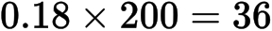 (36 may be seen as a line on the graph) (A1)
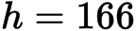 (cm) A1 N2
METHOD 2
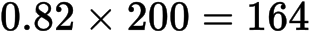 (164 may be seen as a line on the graph) (A1)
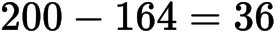(A1)
(cm) A1 N2
[3 marks]
6a. [2 marks]
Consider the following cumulative frequency table.

Markscheme
valid approach (M1)
eg , 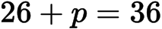
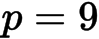A1 N2
[2 marks]
6b. [4 marks]

Markscheme
(i) mean 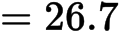A2 N2
(ii) recognizing that variance is (sd)(M1)
eg 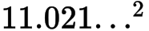 , 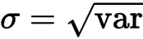 , 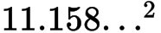
A1 N2
[4 marks]
7. [7 marks]

Markscheme
recognizing one quartile probability (may be seen in a sketch) (M1)
eg 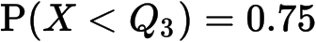 , 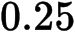
finding standardized value for either quartile (A1)
eg 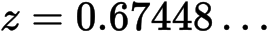 , 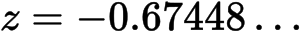
attempt to set up equation (must be with -values) (M1)
eg 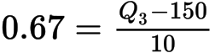 , 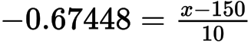
one correct quartile
eg ,
correct working (A1)
eg other correct quartile, 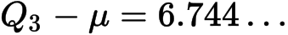
valid approach for IQR (seen anywhere) (A1)
eg , 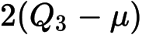
IQR 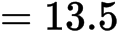A1 N4
[7 marks]
8a. [4 marks]
A running club organizes a race to select girls to represent the club in a competition.
The times taken by the group of girls to complete the race are shown in the table below.

Markscheme
attempt to find (M1)
eg ,
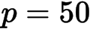A1 N2
attempt to find (M1)
eg ,
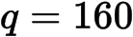A1 N2
[4 marks]
8b. [3 marks]

Markscheme
(i) 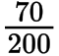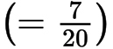A1 N1
(ii) valid approach (M1)
eg ,
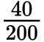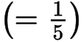A1 N2
[3 marks]
8c. [4 marks]

Markscheme
(i) attempt to find number of girls (M1)
eg 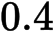, 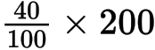
are not selected A1 N2
(ii) are selected (A1)
A1 N2
[4 marks]
8d. [4 marks]

Markscheme
(i) given second chance A1 N1
(ii) took less than minutes (A1)
attempt to find their selected total (may be seen in calculation) (M1)
eg 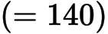 , 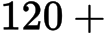 their answer from (i)
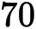 () A1 N3
[4 marks]
9a. [1 mark]
The weights in grams of 80 rats are shown in the following cumulative frequency diagram.
Do NOT write solutions on this page.

Markscheme
50 (g) A1 N1
[2 marks]
9b. [3 marks]

Markscheme
65 rats weigh less than 70 grams (A1)
attempt to find a percentage (M1)
eg 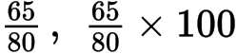
81.25 (%) (exact), 81.3 A1 N3
[2 marks]
9c. [2 marks]

Markscheme
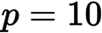A2 N2
[2 marks]
9d. [2 marks]

Markscheme
subtracting to find (M1)
eg 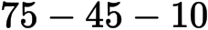
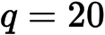A1 N2
[2 marks]
9e. [3 marks]

Markscheme
evidence of mid-interval values (M1)
eg 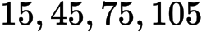
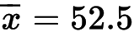 (exact), 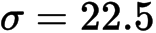 (exact) A1A1 N3
[3 marks]
9f. [2 marks]

Markscheme
0.781650
78.2 (%) A2 N2
[2 marks]
9g. [3 marks]

Markscheme
recognize binomial probability (M1)
eg 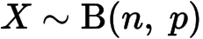, 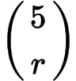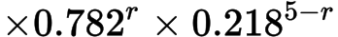
valid approach (M1)
eg 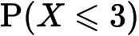
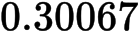
A1 N2
[3 marks]
10a. [2 marks]
The following is a cumulative frequency diagram for the time t, in minutes, taken by 80 students to complete a task.

Markscheme
attempt to find number who took less than 45 minutes (M1)
eg line on graph (vertical at approx 45, or horizontal at approx 70)
70 students (accept 69) A1 N2
[2 marks]
10b. [3 marks]

Markscheme
55 students completed task in less than 35 minutes (A1)
subtracting their values (M1)
eg 70 – 55
15 students A1 N2
[3 marks]
10c. [2 marks]

Markscheme
correct approach (A1)
eg line from y-axis on 50
A1 N2
[2 marks]
11a. [1 mark]
The following is a cumulative frequency diagram for the time t, in minutes, taken by 80 students to complete a task.

Markscheme
median A1 N1
[1 mark]
11b. [3 marks]

Markscheme
lower quartile 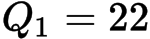 , upper quartile 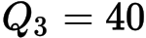(A1)(A1)
A1 N3
[3 marks]
11c. [2 marks]

Markscheme
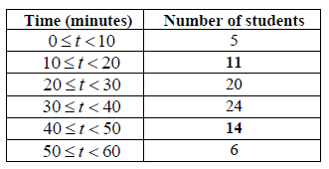 A1A1 N2
[2 marks]
12a. [3 marks]
In a school with 125 girls, each student is tested to see how many sit-up exercises (sit-ups) she can do in one minute. The results are given in the table below.

Markscheme
(i) 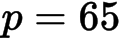A1 N1
(ii) for evidence of using sum is 125 (or ) (M1)
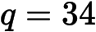A1 N2
[3 marks]
12b. [2 marks]

Markscheme
evidence of median position (M1)
e.g. 63rd student, 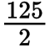
median is 17 (sit-ups) A1 N2
[2 marks]
12c. [2 marks]

Markscheme
evidence of substituting into 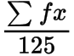 (M1)
e.g. 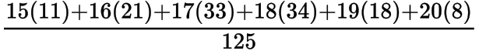 , 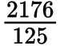
mean 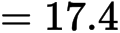A1 N2
[2 marks]
13a. [2 marks]
A box contains 100 cards. Each card has a number between one and six written on it. The following table shows the frequencies for each number.

Markscheme
evidence of using 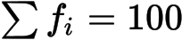(M1)
A1 N2
[2 marks]
13b. [5 marks]

Markscheme
(i) evidence of median position (M1)
e.g. 50th item, 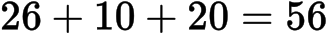
A1 N2
(ii) 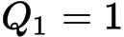 and 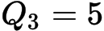(A1)(A1)
(accept 1 to 5 or , etc.) A1 N3
[5 marks]
14a. [3 marks]
A fisherman catches 200 fish to sell. He measures the lengths, l cm of these fish, and the results are shown in the frequency table below.

Markscheme
evidence of using mid-interval values (5, 15, 25, 35, 50, 67.5, 87.5) (M1)
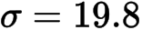 (cm) A2 N3
[3 marks]
14b. [6 marks]

Markscheme
(i) 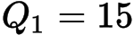 , 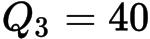(A1)(A1)
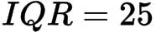 (accept any notation that suggests the interval 15 to 40) A1 N3
(ii) METHOD 1
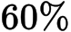 have a length less than k (A1)
(A1)
(cm) A1 N2
METHOD 2
(A1)
(A1)
(cm) A1 N2
[6 marks]
14c. [2 marks]

Markscheme
(M1)
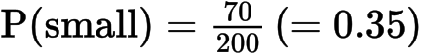A1 N2
[2 marks]
14d. [2 marks]

Markscheme
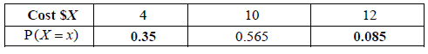 A1A1 N2
[2 marks]
14e. [2 marks]

Markscheme
correct substitution (of their p values) into formula for 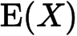 (A1)
e.g.
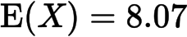 (accept ) A1 N2
[2 marks]
15a. [1 mark]
The following diagram is a box and whisker plot for a set of data.
The interquartile range is 20 and the range is 40.

Markscheme
18 A1 N1
[1 mark]
15b. [4 marks]

Markscheme
(i) 10 A2 N2
(ii) 44 A2 N2
[4 marks]
16a. [2 marks]
A standard die is rolled 36 times. The results are shown in the following table.

Markscheme
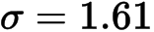A2 N2
[2 marks]
16b. [1 mark]

Markscheme
median 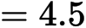A1 N1
[1 mark]
16c. [3 marks]

Markscheme
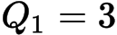 , 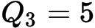 (may be seen in a box plot) (A1)(A1)
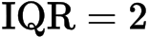 (accept any notation that suggests the interval 3 to 5) A1 N3
[3 marks]
17a. [4 marks]
The following frequency distribution of marks has mean 4.5.

Markscheme
, 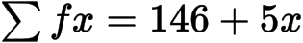 (seen anywhere) A1
evidence of substituting into mean 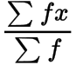(M1)
correct equation A1
e.g. 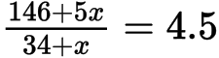 , 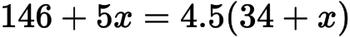
A1 N2
[4 marks]
17b. [2 marks]

Markscheme
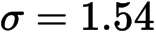A2 N2
[2 marks]
18a. [4 marks]
The following table gives the examination grades for 120 students.

Markscheme
(a) (i) evidence of appropriate approach (M1)
e.g. 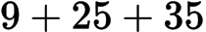 , 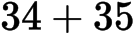
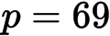 A1 N2
(ii) evidence of valid approach (M1)
e.g. 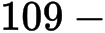their value of p, 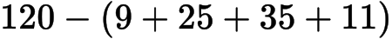
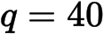A1 N2
[4 marks]
18b. [2 marks]

Markscheme
evidence of appropriate approach (M1)
e.g. substituting into 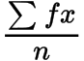, division by 120
mean 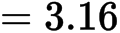A1 N2
[2 marks]
18c. [1 mark]

Markscheme
1.09 A1 N1
[1 mark]
19a. [2 marks]
There are nine books on a shelf. For each book, x is the number of pages, and y is the selling price in pounds (£). Let r be the correlation coefficient.

Markscheme
min value of r is , max value of r is 1 A1A1 N2
[2 marks]
19b. [1 mark]

Markscheme
C A1 N1
[1 mark]
19c. [2 marks]

Markscheme
linear, strong negative A1A1 N2
[2 marks]
20a. [2 marks]
A data set has a mean of 20 and a standard deviation of 6.

Markscheme
(i) new mean is A1 N1
(ii) new sd is 6 A1 N1
[2 marks]
20b. [3 marks]

Markscheme
(i) new mean is A1 N1
(ii) METHOD 1
variance is 36 A1
new variance is A1 N2
METHOD 2
new sd is 60 A1
new variance is A1 N2
[3 marks]
21a. [3 marks]
A scientist has 100 female fish and 100 male fish. She measures their lengths to the nearest cm. These are shown in the following box and whisker diagrams.

Markscheme
correct end points (A1)(A1)
max = 27 , min = 4
range = 23 A1 N3
[3 marks]
21b. [2 marks]

Markscheme
Graph 3 A2 N2
[2 marks]

Printed for British School of Beijing
© International Baccalaureate Organization 2015
International Baccalaureate® - Baccalauréat International® - Bachillerato Internacional®

