Chp 3 & 4 Questions
1a. [4 marks]
Let 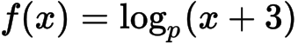 for 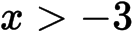 . Part of the graph of f is shown below.
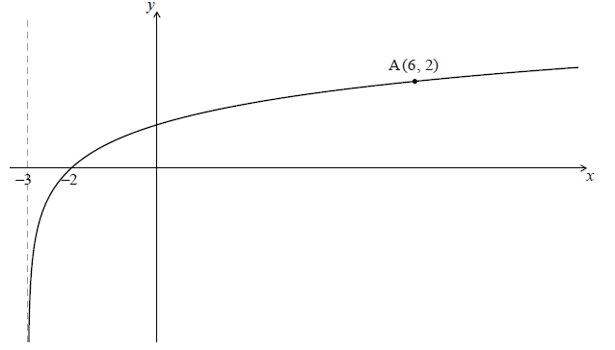
The graph passes through A(6, 2) , has an x-intercept at (−2, 0) and has an asymptote at .
Find p .
1b. [5 marks]
The graph of f is reflected in the line to give the graph of g .
(i) Write down the y-intercept of the graph of g .
(ii) Sketch the graph of g , noting clearly any asymptotes and the image of A.
1c. [4 marks]
The graph of is reflected in the line to give the graph of .
Find 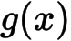 .
2a. [1 mark]
Jose takes medication. After t minutes, the concentration of medication left in his bloodstream is given by 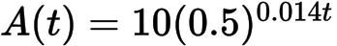 , where A is in milligrams per litre.
Write down 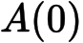 .
2b. [2 marks]
Find the concentration of medication left in his bloodstream after 50 minutes.
2c. [5 marks]
At 13:00, when there is no medication in Jose’s bloodstream, he takes his first dose of medication. He can take his medication again when the concentration of medication reaches 0.395 milligrams per litre. What time will Jose be able to take his medication again?
3a. [2 marks]
Let , for 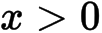 .
Show that 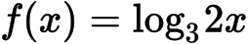 .
3b. [3 marks]
Find the value of 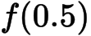 and of 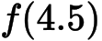 .
3c. [6 marks]
The function f can also be written in the form 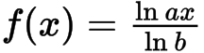 .
(i) Write down the value of a and of b .
(ii) Hence on graph paper, sketch the graph of f , for 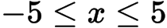 , 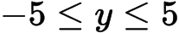 , using a scale of 1 cm to 1 unit on each axis.
(iii) Write down the equation of the asymptote.
3d. [1 mark]
Write down the value of 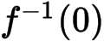 .
3e. [4 marks]
The point A lies on the graph of f . At A, 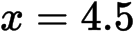 .
On your diagram, sketch the graph of 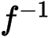 , noting clearly the image of point A.
4a. [4 marks]
Let 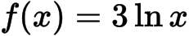 and 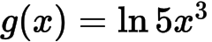 .
Express in the form 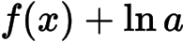 , where 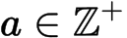 .
4b. [3 marks]
The graph of g is a transformation of the graph of f . Give a full geometric description of this transformation.
5a. [3 marks]
Find the value of 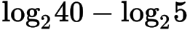 .
5b. [4 marks]
Find the value of 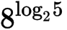 .
6a. [7 marks]
Let 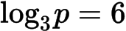 and 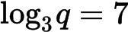 .
(a) Find 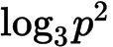 .
(b) Find 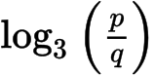 .
(c) Find 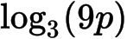 .
6b. [2 marks]
Find .
6c. [2 marks]
Find .
6d. [3 marks]
Find .
7a. [7 marks]
Let 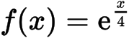 and 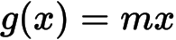 , where 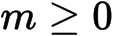 , and . Let 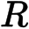 be the region enclosed by the -axis, the graph of , and the graph of .
Let .
(i) Sketch the graphs of and on the same axes.
(ii) Find the area of .
7b. [5 marks]
Find the area of .
7c. [8 marks]
Consider all values of such that the graphs of and intersect. Find the value of that gives the greatest value for the area of .
8a. [1 mark]
Write down the value of
(i) 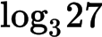;
8b. [1 mark]
(ii) 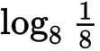;
8c. [1 mark]
(iii) 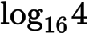.
8d. [3 marks]
Hence, solve .
9a. [2 marks]
Find the value of each of the following, giving your answer as an integer.
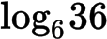
9b. [2 marks]
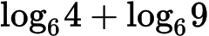
9c. [3 marks]
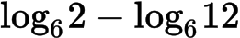
10a. [2 marks]
The number of bacteria in two colonies, 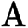 and , starts increasing at the same time.
The number of bacteria in colony after hours is modelled by the function 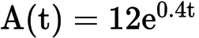.
Find the number of bacteria in colony after four hours.
10b. [3 marks]
Find the number of bacteria in colony after four hours.
10c. [3 marks]
How long does it take for the number of bacteria in colony to reach 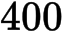?
10d. [3 marks]
The number of bacteria in colony after hours is modelled by the function 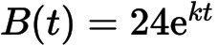.
After four hours, there are 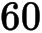 bacteria in colony . Find the value of .
10e. [4 marks]
The number of bacteria in colony after hours is modelled by the function .
The number of bacteria in colony first exceeds the number of bacteria in colony after hours, where 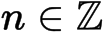. Find the value of .

Printed for British School of Beijing
© International Baccalaureate Organization 2015
International Baccalaureate® - Baccalauréat International® - Bachillerato Internacional®

Chp 3 & 4 Questions
1a. [4 marks]
Let 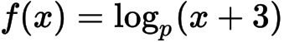 for 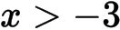 . Part of the graph of f is shown below.
The graph passes through A(6, 2) , has an x-intercept at (−2, 0) and has an asymptote at .

Markscheme
evidence of substituting the point A (M1)
e.g. 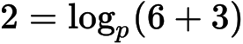
manipulating logs A1
e.g. 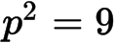
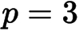A2 N2
[4 marks]
1b. [5 marks]

Markscheme
(i) 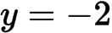 (accept A1 N1
(ii)
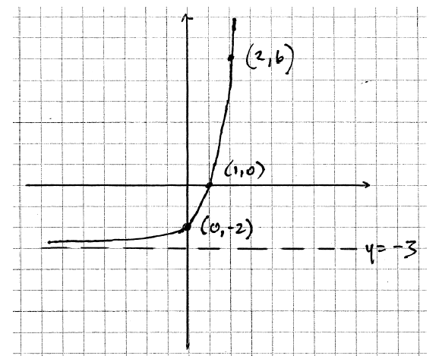 A1A1A1A1 N4
Note: Award A1 for asymptote at 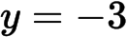 , A1 for an increasing function that is concave up, A1 for a positive x-intercept and a negative y-intercept, A1 for passing through the point 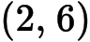 .
[5 marks]
1c. [4 marks]

Markscheme
METHOD 1
recognizing that 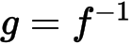(R1)
evidence of valid approach (M1)
e.g. switching x and y (seen anywhere), solving for x
correct manipulation (A1)
e.g. 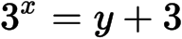
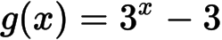A1 N3
METHOD 2
recognizing that 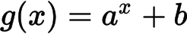(R1)
identifying vertical translation (A1)
e.g. graph shifted down 3 units, 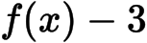
evidence of valid approach (M1)
e.g. substituting point to identify the base
A1 N3
[4 marks]
2a. [1 mark]
Jose takes medication. After t minutes, the concentration of medication left in his bloodstream is given by 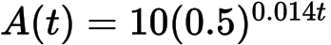 , where A is in milligrams per litre.

Markscheme
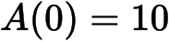A1 N1
[1 mark]
2b. [2 marks]

Markscheme
substitution into formula (A1)
e.g. 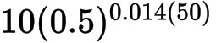 , 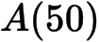
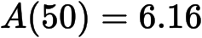A1 N2
[2 marks]
2c. [5 marks]

Markscheme
set up equation (M1)
e.g. 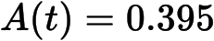
attempting to solve (M1)
e.g. graph, use of logs
correct working (A1)
e.g. sketch of intersection,
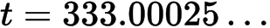A1
correct time 18:33 or 18:34 (accept 6:33 or 6:34 but nothing else) A1 N3
[5 marks]
3a. [2 marks]
Let , for 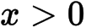 .

Markscheme
combining 2 terms (A1)
e.g. 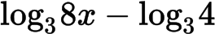 , 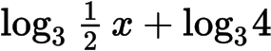
expression which clearly leads to answer given A1
e.g. 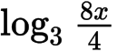 , 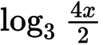
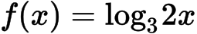AG N0
[2 marks]
3b. [3 marks]

Markscheme
attempt to substitute either value into f (M1)
e.g. 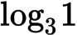 , 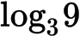
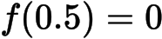 , 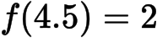A1A1 N3
[3 marks]
3c. [6 marks]

Markscheme
(i) , A1A1 N1N1
(ii)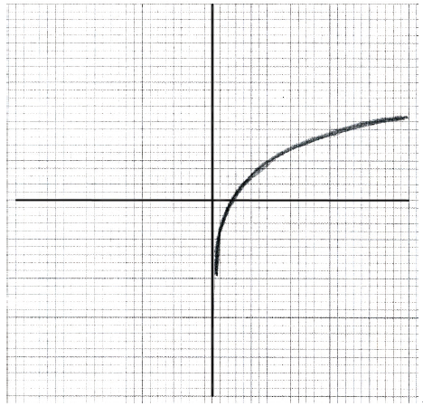 A1A1A1 N3
Note: Award A1 for sketch approximately through 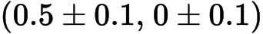 , A1 for approximately correct shape, A1 for sketch asymptotic to the y-axis.
(iii) (must be an equation) A1 N1
[6 marks]
3d. [1 mark]

Markscheme
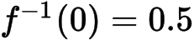A1 N1
[1 mark]
3e. [4 marks]

Markscheme
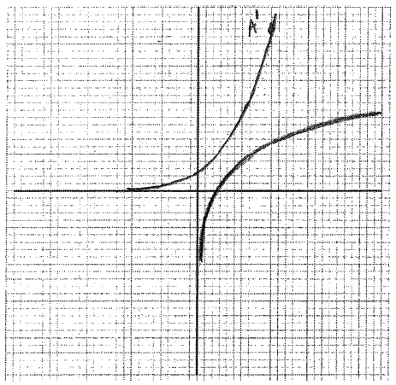 A1A1A1A1 N4
Note: Award A1 for sketch approximately through 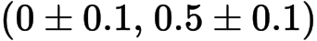 , A1 for approximately correct shape of the graph reflected over , A1 for sketch asymptotic to x-axis, A1 for point 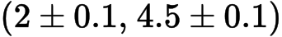 clearly marked and on curve.
[4 marks]
4a. [4 marks]
Let 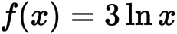 and 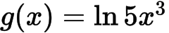 .

Markscheme
attempt to apply rules of logarithms (M1)
e.g. 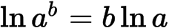 , 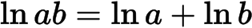
correct application of (seen anywhere) A1
e.g. 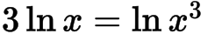
correct application of (seen anywhere) A1
e.g. 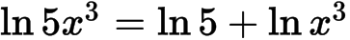
so 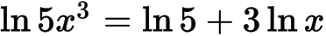
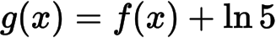 (accept 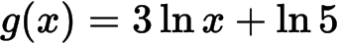 ) A1 N1
[4 marks]
4b. [3 marks]

Markscheme
transformation with correct name, direction, and value A3
e.g. translation by 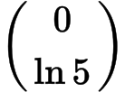, shift up by 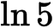 , vertical translation of
[3 marks]
5a. [3 marks]

Markscheme
evidence of correct formula (M1)
eg 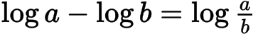 , 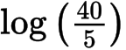 , 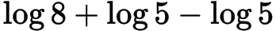
Note: Ignore missing or incorrect base.
correct working (A1)
eg 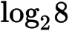 , 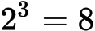
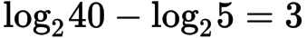A1 N2
[3 marks]
5b. [4 marks]

Markscheme
attempt to write as a power of (seen anywhere) (M1)
eg 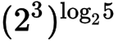 , , 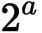
multiplying powers (M1)
eg 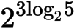 , 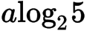
correct working (A1)
eg 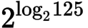 , 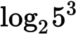 , 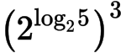
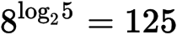A1 N3
[4 marks]
6a. [7 marks]
Let 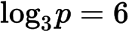 and 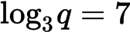 .

Markscheme
(a) METHOD 1
evidence of correct formula (M1)
eg 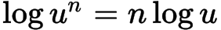 , 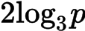
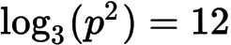A1 N2
METHOD 2
valid method using 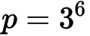(M1)
eg 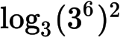 , 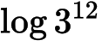 , 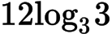
A1 N2
[2 marks]
(b) METHOD 1
evidence of correct formula (M1)
eg 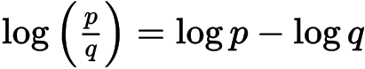 ,
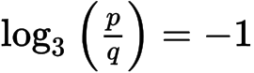A1 N2
METHOD 2
valid method using and 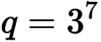(M1)
eg 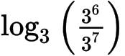 , 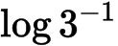 , 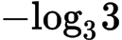
A1 N2
[2 marks]
(c) METHOD 1
evidence of correct formula (M1)
eg 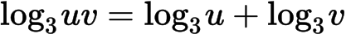 , 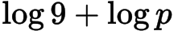
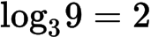 (may be seen in expression) A1
eg 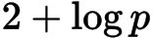
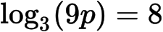A1 N2
METHOD 2
valid method using (M1)
eg 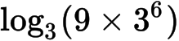 , 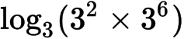
correct working A1
eg 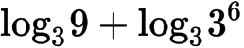 , 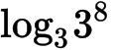
A1 N2
[3 marks]
Total [7 marks]
6b. [2 marks]

Markscheme
METHOD 1
evidence of correct formula (M1)
eg ,
A1 N2
METHOD 2
valid method using (M1)
eg , ,
A1 N2
[2 marks]
6c. [2 marks]

Markscheme
METHOD 1
evidence of correct formula (M1)
eg ,
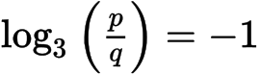A1 N2
METHOD 2
valid method using 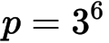 and 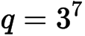(M1)
eg 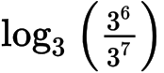 , 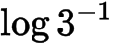 , 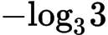
A1 N2
[2 marks]
6d. [3 marks]

Markscheme
METHOD 1
evidence of correct formula (M1)
eg 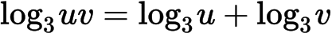 , 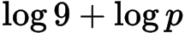
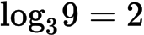 (may be seen in expression) A1
eg 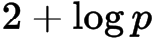
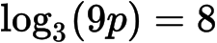A1 N2
METHOD 2
valid method using (M1)
eg 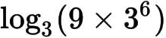 , 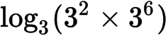
correct working A1
eg 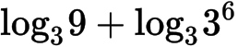 , 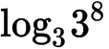
A1 N2
[3 marks]
Total [7 marks]
7a. [7 marks]
Let 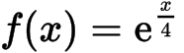 and 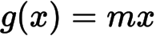 , where 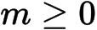 , and 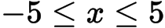 . Let 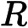 be the region enclosed by the -axis, the graph of , and the graph of .
Let .

Markscheme
(i)
A1A1 N2
Notes: Award A1 for the graph of positive, increasing and concave up.
Award A1 for graph of increasing and linear with -intercept of .
Penalize one mark if domain is not [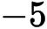, ] and/or if and do not intersect in the first quadrant.
[2 marks]
(ii)attempt to find intersection of the graphs of and (M1)eg 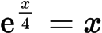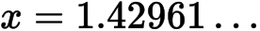 A1valid attempt to find area of (M1)eg 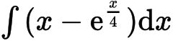 , 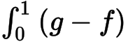 , 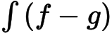area 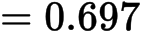 A2 N3[5 marks]
7b. [5 marks]

Markscheme
attempt to find intersection of the graphs of and (M1)
eg
A1
valid attempt to find area of (M1)
eg , ,
area A2 N3
[5 marks]
7c. [8 marks]

Markscheme
recognize that area of is a maximum at point of tangency (R1)
eg 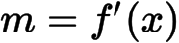
equating functions (M1)
eg 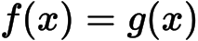 , 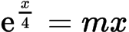
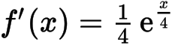 (A1)
equating gradients (A1)
eg 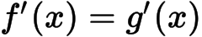 , 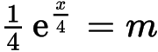
attempt to solve system of two equations for (M1)
eg 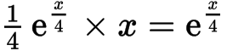
(A1)
attempt to find (M1)
eg 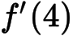 , 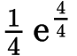
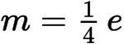 (exact), 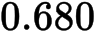A1 N3
[8 marks]
8a. [1 mark]
Write down the value of

Markscheme
(i) 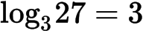A1 N1
[1 mark]
8b. [1 mark]

Markscheme
(ii) 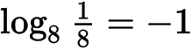A1 N1
[1 mark]
8c. [1 mark]

Markscheme
(iii) 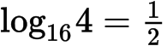A1 N1
[1 mark]
8d. [3 marks]

Markscheme
correct equation with their three values (A1)
eg
correct working involving powers (A1)
eg 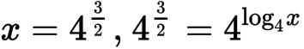
A1 N2
[3 marks]
9a. [2 marks]
Find the value of each of the following, giving your answer as an integer.

Markscheme
correct approach (A1)
eg 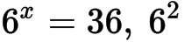
A1 N2
[2 marks]
9b. [2 marks]

Markscheme
correct simplification (A1)
eg 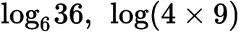
A1 N2
[2 marks]
9c. [3 marks]

Markscheme
correct simplification (A1)
eg 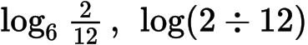
correct working (A1)
eg 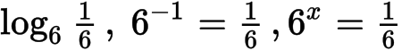
A1 N2
[3 marks]
10a. [2 marks]
The number of bacteria in two colonies, 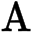 and , starts increasing at the same time.
The number of bacteria in colony after hours is modelled by the function 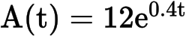.

Markscheme
correct substitution into formula (A1)
eg 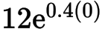
bacteria in the dish A1 N2
[2 marks]
10b. [3 marks]

Markscheme
correct substitution into formula (A1)
eg 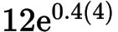
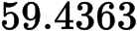(A1)
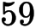 bacteria in the dish (integer answer only) A1 N3
[3 marks]
10c. [3 marks]

Markscheme
correct equation (A1)
eg 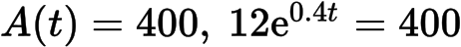
valid attempt to solve (M1)
eg graph, use of logs
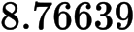
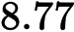 (hours) A1 N3
[3 marks]
10d. [3 marks]

Markscheme
valid attempt to solve (M1)
eg 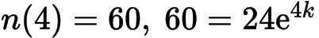, use of logs
correct working (A1)
eg sketch of intersection, 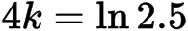
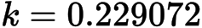
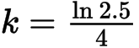 (exact), 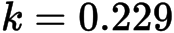A1 N3
[3 marks]
10e. [4 marks]

Markscheme
METHOD 1
setting up an equation or inequality (accept any variable for ) (M1)
eg
correct working (A1)
eg sketch of intersection, 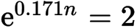
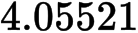 (accept 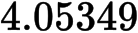) (A1)
(integer answer only) A1 N3
METHOD 2
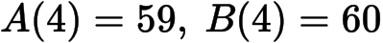 (from earlier work)
A1A1
valid reasoning (R1)
eg 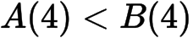and 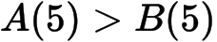
(integer answer only) A1 N3
[4 marks]

Printed for British School of Beijing
© International Baccalaureate Organization 2015
International Baccalaureate® - Baccalauréat International® - Bachillerato Internacional®

