Chp 5 IB SL Maths
1a. [4 marks]
Consider the function 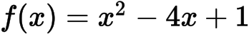 .
Sketch the graph of f , for 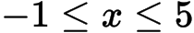 .
1b. [1 mark]
This function can also be written as 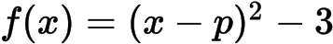 .
Write down the value of p .
1c. [4 marks]
The graph of g is obtained by reflecting the graph of f in the x-axis, followed by a translation of 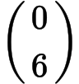 .
Show that 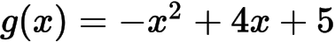 .
1d. [3 marks]
The graph of g is obtained by reflecting the graph of f in the x-axis, followed by a translation of .
The graphs of f and g intersect at two points.
Write down the x-coordinates of these two points.
1e. [3 marks]
The graph of is obtained by reflecting the graph of in the x-axis, followed by a translation of .
Let R be the region enclosed by the graphs of f and g .
Find the area of R .
2a. [2 marks]
The diagram below shows the graph of a function 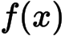 , for 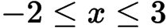 .
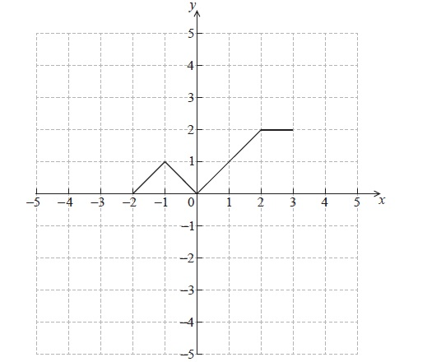
Sketch the graph of 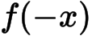 on the grid below.
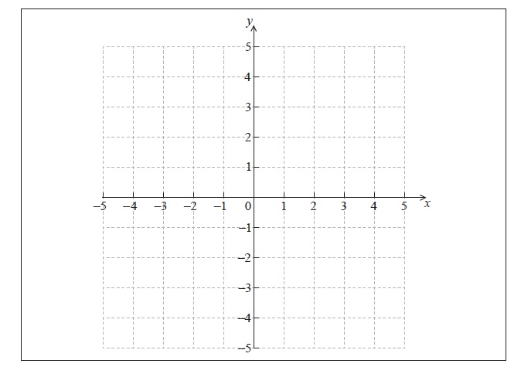
2b. [4 marks]
The graph of f is transformed to obtain the graph of g . The graph of g is shown below.
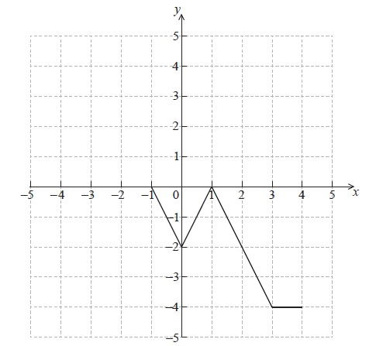
The function g can be written in the form 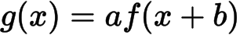 . Write down the value of a and of b .
3a. [3 marks]
The diagram below shows the graph of a function 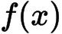 , for 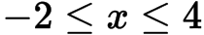 .
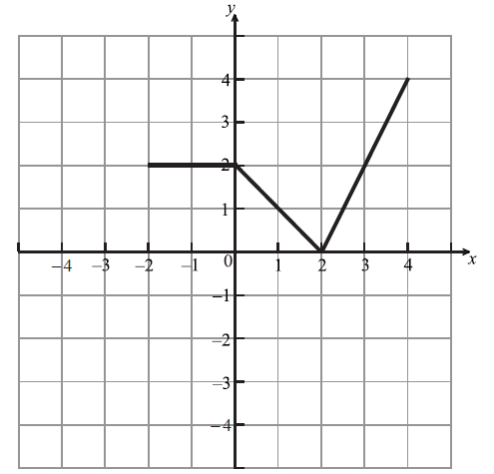
Let 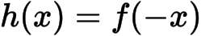 . Sketch the graph of on the grid below.
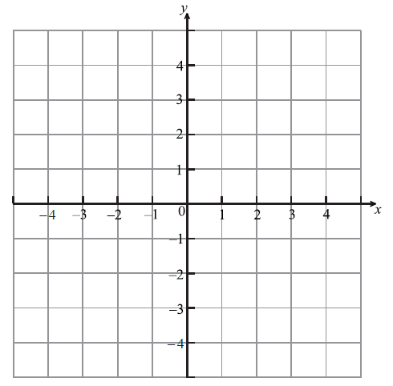
3b. [3 marks]
Let 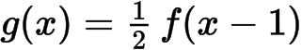. The point 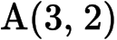 on the graph of is transformed to the point P on the graph of . Find the coordinates of P.
4a. [2 marks]
Let 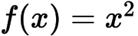 and 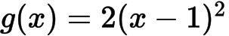 .
The graph of g can be obtained from the graph of f using two transformations.
Give a full geometric description of each of the two transformations.
4b. [4 marks]
The graph of g is translated by the vector 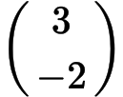 to give the graph of h.
The point 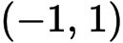 on the graph of f is translated to the point P on the graph of h.
Find the coordinates of P.
5a. [2 marks]
Let 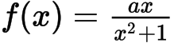 , 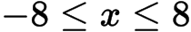 , 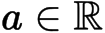 .The graph of f is shown below.
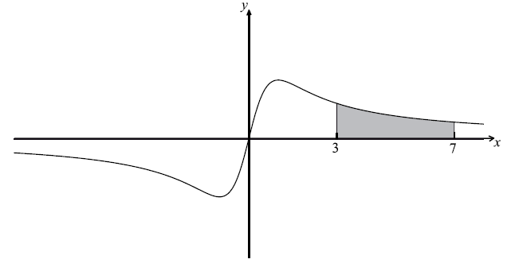
The region between and is shaded.
Show that 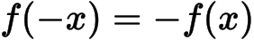 .
5b. [7 marks]
Given that 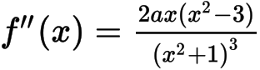 , find the coordinates of all points of inflexion.
5c. [7 marks]
It is given that .
(i) Find the area of the shaded region, giving your answer in the form 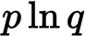 .
(ii) Find the value of 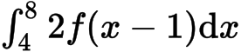 .
6a. [2 marks]
Let 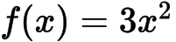 . The graph of f is translated 1 unit to the right and 2 units down. The graph of g is the image of the graph of f after this translation.
Write down the coordinates of the vertex of the graph of g .
6b. [2 marks]
Express g in the form 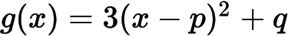 .
6c. [2 marks]
The graph of h is the reflection of the graph of g in the x-axis.
Write down the coordinates of the vertex of the graph of h .
7a. [6 marks]
Let and be functions such that 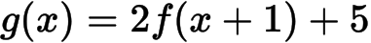 .
(a) The graph of is mapped to the graph of under the following transformations:
vertical stretch by a factor of , followed by a translation 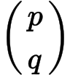.
Write down the value of
(i) ;
(ii) ;
(iii) .
(b) Let 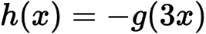 . The point A(, ) on the graph of is mapped to the point 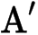 on the graph of . Find .
7b. [3 marks]
The graph of is mapped to the graph of under the following transformations:
vertical stretch by a factor of , followed by a translation .
Write down the value of
(i) ;
(ii) ;
(iii) .
7c. [3 marks]
Let . The point A(, ) on the graph of is mapped to the point on the graph of . Find .
8a. [2 marks]
Let 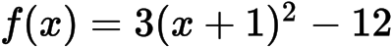 .
Show that 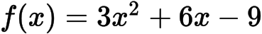 .
8b. [8 marks]
For the graph of f
(i) write down the coordinates of the vertex;
(ii) write down the equation of the axis of symmetry;
(iii) write down the y-intercept;
(iv) find both x-intercepts.
8c. [2 marks]
Hence sketch the graph of f .
8d. [3 marks]
Let 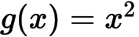 . The graph of f may be obtained from the graph of g by the two transformations:
a stretch of scale factor t in the y-direction
followed by a translation of 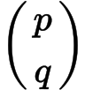 .
Find and the value of t.
9a. [2 marks]
Part of the graph of a function f is shown in the diagram below.
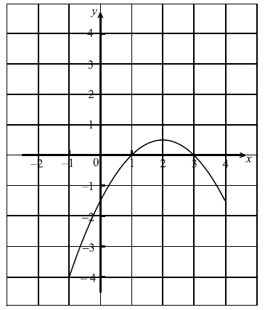
On the same diagram sketch the graph of 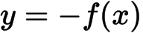 .
9b. [4 marks]
Let 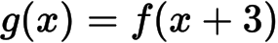 .
(i) Find 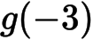 .
(ii) Describe fully the transformation that maps the graph of f to the graph of g.
10a. [2 marks]
Consider the graph of shown below.
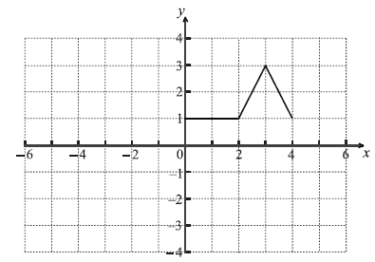
On the same grid sketch the graph of 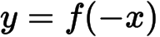 .
10b. [2 marks]
The following four diagrams show images of f under different transformations.
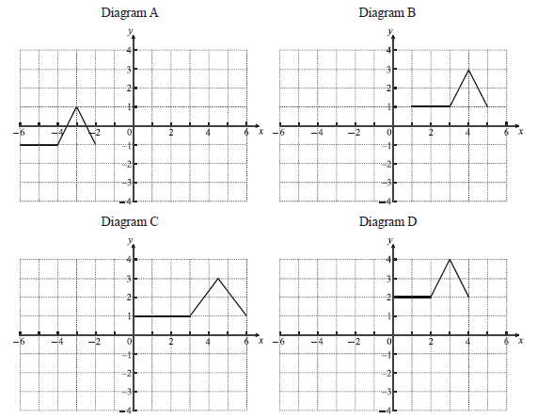
Complete the following table.
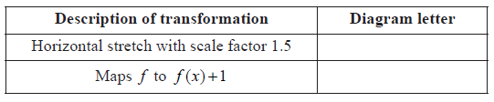
10c. [2 marks]
Give a full geometric description of the transformation that gives the image in Diagram A.
Printed for British School of Beijing
© International Baccalaureate Organization 2015
International Baccalaureate® - Baccalauréat International® - Bachillerato Internacional®

Chp 5 IB SL Maths
1a. [4 marks]
Consider the function 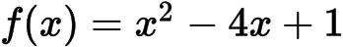 .

Markscheme
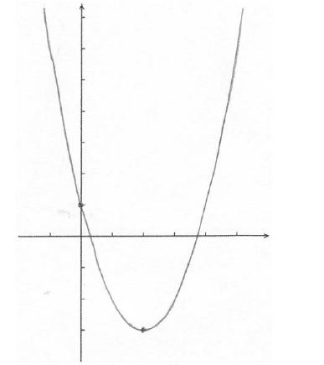A1A1A1A1 N4
Note: The shape must be an approximately correct upwards parabola.
Only if the shape is approximately correct, award the following:
A1 for vertex , A1 for x-intercepts between 0 and 1, and 3 and 4, A1 for correct y-intercept 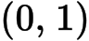, A1 for correct domain 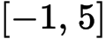.
Scale not required on the axes, but approximate positions need to be clear.
[4 marks]
1b. [1 mark]

Markscheme
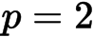A1 N1
[1 mark]
1c. [4 marks]

Markscheme
correct vertical reflection, correct vertical translation (A1)(A1)
e.g. 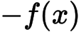 , 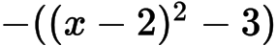 , , 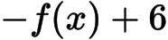 , 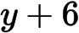
transformations in correct order (A1)
e.g. 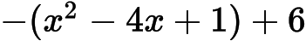 , 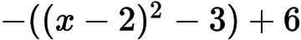
simplification which clearly leads to given answer A1
e.g. 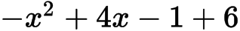 , 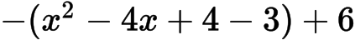
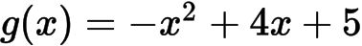AG N0
Note: If working shown, award A1A1A0A0 if transformations correct, but done in reverse order, e.g. 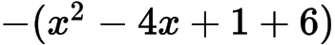.
[4 marks]
1d. [3 marks]

Markscheme
valid approach (M1)
e.g. sketch, 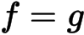
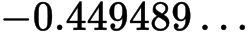 ,
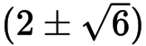 (exact), ; 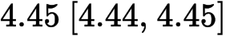A1A1 N3
[3 marks]
1e. [3 marks]

Markscheme
attempt to substitute limits or functions into area formula (accept absence of 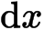 ) (M1)
e.g. , 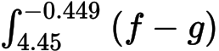 , 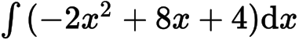
approach involving subtraction of integrals/areas (accept absence of ) (M1)
e.g. , 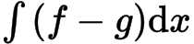
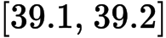A1 N3
[3 marks]
2a. [2 marks]
The diagram below shows the graph of a function 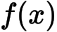 , for 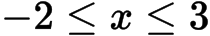 .

Markscheme
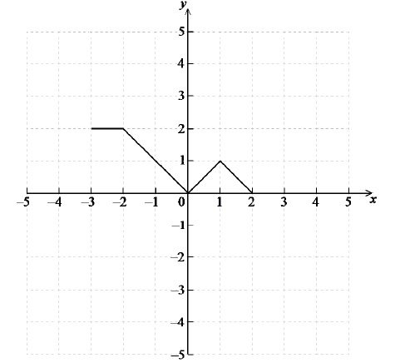A2 N2
[2 marks]
2b. [4 marks]

Markscheme
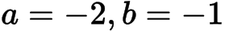A2A2 N4
Note: Award A1 for , A1 for .
[4 marks]
3a. [3 marks]
The diagram below shows the graph of a function 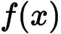 , for 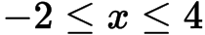 .

Markscheme
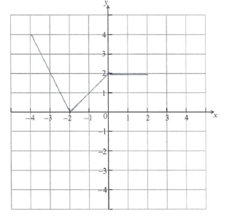 A2 N2
[2 marks]
3b. [3 marks]

Markscheme
evidence of appropriate approach (M1)
e.g. reference to any horizontal shift and/or stretch factor, 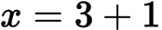 , 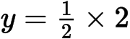
P is 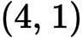 (accept , 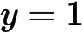) A1A1 N3
[3 marks]
4a. [2 marks]
Let 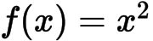 and 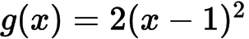 .

Markscheme
in any order
translated 1 unit to the right A1 N1
stretched vertically by factor 2 A1 N1
[2 marks]
4b. [4 marks]

Markscheme
METHOD 1
finding coordinates of image on g (A1)(A1)
e.g. 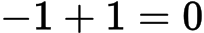 , , , 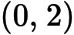
P is (3, 0) A1A1 N4
METHOD 2
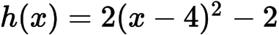(A1)(A1)
P is 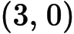A1A1 N4
5a. [2 marks]
Let 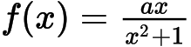 , 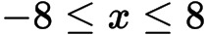 , 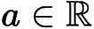 .The graph of f is shown below.
The region between and is shaded.

Markscheme
METHOD 1
evidence of substituting for (M1)
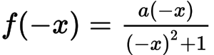A1
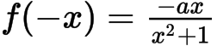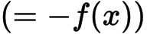AG N0
METHOD 2
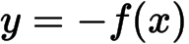 is reflection of 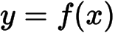 in x axis
and 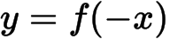 is reflection of in y axis (M1)
sketch showing these are the same A1
AG N0
[2 marks]
5b. [7 marks]

Markscheme
evidence of appropriate approach (M1)
e.g. 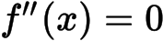
to set the numerator equal to 0 (A1)
e.g. ; 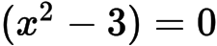
(0, 0) , 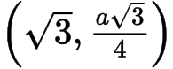 , 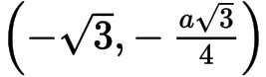 (accept , 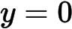 etc) A1A1A1A1A1 N5
[7 marks]
5c. [7 marks]

Markscheme
(i) correct expression A2
e.g. 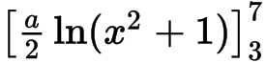 , , 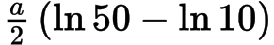
area = 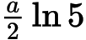A1A1 N2
(ii) METHOD 1
recognizing the shift that does not change the area (M1)
e.g. 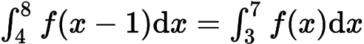 ,
recognizing that the factor of 2 doubles the area (M1)
e.g. 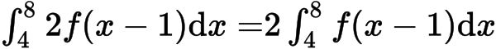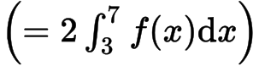
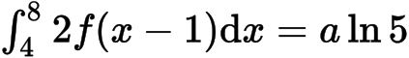 (i.e. their answer to (c)(i)) A1 N3
METHOD 2
changing variable
let , so 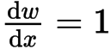
(M1)
substituting correct limits
e.g. 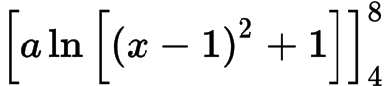 , 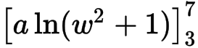 , (M1)
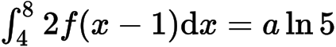A1 N3
[7 marks]
6a. [2 marks]
Let 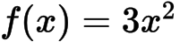 . The graph of f is translated 1 unit to the right and 2 units down. The graph of g is the image of the graph of f after this translation.

Markscheme
A1A1 N2
[2 marks]
6b. [2 marks]

Markscheme
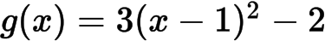 (accept 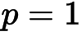 , 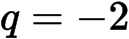 ) A1A1 N2
[2 marks]
6c. [2 marks]

Markscheme
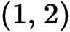A1A1 N2
[2 marks]
7a. [6 marks]
Let and be functions such that 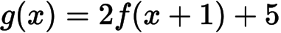 .

Markscheme
(a) (i) A1 N1
(ii) 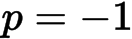A1 N1
(iii) 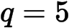A1 N1
[3 marks]
(b) recognizing one transformation (M1)
eg horizontal stretch by , reflection in -axis
is (, 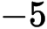) A1A1 N3
[3 marks]
Total [6 marks]
7b. [3 marks]

Markscheme
(i) A1 N1
(ii) A1 N1
(iii) A1 N1
[3 marks]
7c. [3 marks]

Markscheme
recognizing one transformation (M1)
eg horizontal stretch by , reflection in -axis
is (, ) A1A1 N3
[3 marks]
Total [6 marks]
8a. [2 marks]
Let 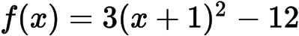 .

Markscheme
A1
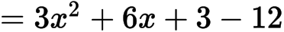A1
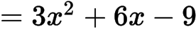AG N0
[2 marks]
8b. [8 marks]

Markscheme
(i) vertex is A1A1 N2
(ii) (must be an equation) A1 N1
(iii) A1 N1
(iv) evidence of solving 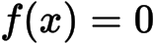(M1)
e.g. factorizing, formula,
correct working A1
e.g. 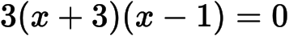 , 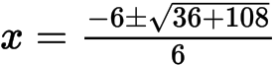
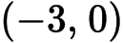, 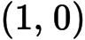A1A1 N1N1
[8 marks]
8c. [2 marks]

Markscheme
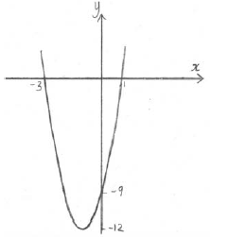 A1A1 N2
Note: Award A1 for a parabola opening upward, A1 for vertex and intercepts in approximately correct positions.
[2 marks]
8d. [3 marks]

Markscheme
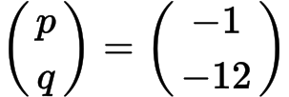 , (accept , 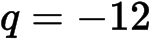 , ) A1A1A1 N3
[3 marks]
9a. [2 marks]
Part of the graph of a function f is shown in the diagram below.

Markscheme
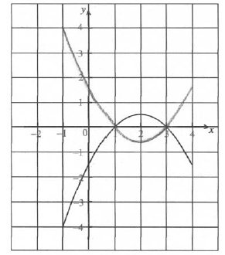 M1A1 N2
Note: Award M1 for evidence of reflection in x-axis, A1 for correct vertex and all intercepts approximately correct.
9b. [4 marks]

Markscheme
(i) 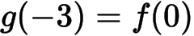 (A1)
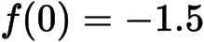A1 N2
(ii) translation (accept shift, slide, etc.) of 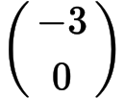A1A1 N2
[4 marks]
10a. [2 marks]
Consider the graph of shown below.

Markscheme
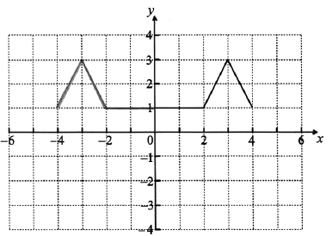 A2 N2
[2 marks]
10b. [2 marks]
The following four diagrams show images of f under different transformations.

Markscheme
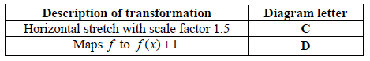 A1A1 N2
[2 marks]
10c. [2 marks]

Markscheme
translation (accept move/shift/slide etc.) with vector 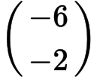A1A1 N2
[2 marks]

Printed for British School of Beijing
© International Baccalaureate Organization 2015
International Baccalaureate® - Baccalauréat International® - Bachillerato Internacional®

