Cp 6 Qs IB SL Maths
1a. [2 marks]
The first three terms of an arithmetic sequence are 5 , 6.7 , 8.4 .
Find the common difference.
1b. [2 marks]
The first three terms of an arithmetic sequence are 5 , 6.7 , 8.4 .
Find the 28term of the sequence.
1c. [2 marks]
The first three terms of an arithmetic sequence are , 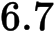 , 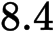 .
Find the sum of the first 28 terms.
2a. [4 marks]
The first term of a geometric sequence is 200 and the sum of the first four terms is 324.8.
Find the common ratio.
2b. [2 marks]
The first term of a geometric sequence is 200 and the sum of the first four terms is 324.8.
Find the tenth term.
3a. [3 marks]
The first three terms of an arithmetic sequence are 36, 40, 44,….
(i) Write down the value of d .
(ii) Find .
3b. [3 marks]
(i) Show that 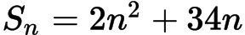 .
(ii) Hence, write down the value of 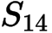 .
4a. [4 marks]
Consider an infinite geometric sequence with 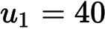 and 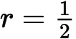.
(i) Find .
(ii) Find the sum of the infinite sequence.
4b. [5 marks]
Consider an arithmetic sequence with n terms, with first term (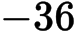) and eighth term (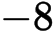) .
(i) Find the common difference.
(ii) Show that 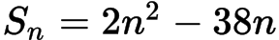 .
4c. [5 marks]
The sum of the infinite geometric sequence is equal to twice the sum of the arithmetic sequence. Find n .
5a. [2 marks]
In an arithmetic sequence, and 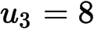 .
Find d .
5b. [2 marks]
Find .
5c. [2 marks]
Find 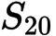 .
6a. [7 marks]
An arithmetic sequence is given by , , , ….
(a) Write down the value of .
(b) Find
(i) ;
(ii) 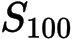 .
(c) Given that 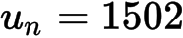 , find the value of .
6b. [1 mark]
Write down the value of .
6c. [4 marks]
Find
(i) ;
(ii) .
6d. [2 marks]
Given that , find the value of .
7. [6 marks]
The sum of the first three terms of a geometric sequence is 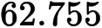, and the sum of the infinite sequence is 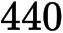. Find the common ratio.
8a. [2 marks]
In an arithmetic sequence, the third term is 10 and the fifth term is 16.
Find the common difference.
8b. [2 marks]
Find the first term.
8c. [3 marks]
Find the sum of the first 20 terms of the sequence.
9a. [4 marks]
The sides of a square are 16 cm in length. The midpoints of the sides of this square are joined to form a new square and four triangles (diagram 1). The process is repeated twice, as shown in diagrams 2 and 3.
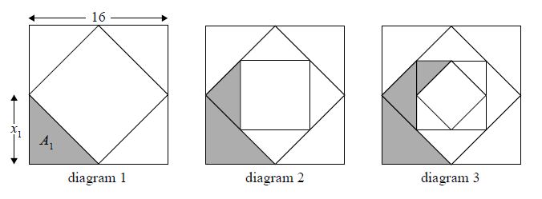
Let denote the length of one of the equal sides of each new triangle.
Let 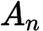 denote the area of each new triangle.
The following table gives the values of and , for 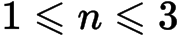. Copy and complete the table. (Do not write on this page.)
 | 1 | 2 | 3
 | 8 |  | 4
 | 32 | 16

9b. [4 marks]
The process described above is repeated. Find 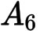.
9c. [7 marks]
Consider an initial square of side length 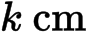. The process described above is repeated indefinitely. The total area of the shaded regions is 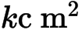. Find the value of .
10a. [4 marks]
The sums of the terms of a sequence follow the pattern
Given that 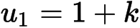, find and .
10b. [4 marks]
Find a general expression for .
11a. [2 marks]
The first three terms of a infinite geometric sequence are 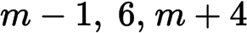, where 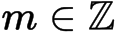.
Write down an expression for the common ratio, .
11b. [2 marks]
Hence, show that satisfies the equation 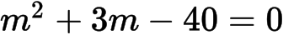.
11c. [3 marks]
Find the two possible values of .
11d. [3 marks]
Find the possible values of .
11e. [3 marks]
The sequence has a finite sum.
State which value of leads to this sum and justify your answer.
11f. [3 marks]
The sequence has a finite sum.
Calculate the sum of the sequence.
12a. [1 mark]
Consider the infinite geometric sequence .
Write down the 10th term of the sequence. Do not simplify your answer.
12b. [4 marks]
Consider the infinite geometric sequence .
Find the sum of the infinite sequence.
13a. [3 marks]
Consider the arithmetic sequence 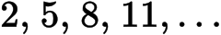 .
Find .
13b. [3 marks]
Consider the arithmetic sequence .
Find the value of n so that 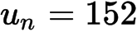 .
14a. [2 marks]
Consider the infinite geometric sequence .
Find the common ratio.
14b. [2 marks]
Find the 10th term.
14c. [2 marks]
Find the exact sum of the infinite sequence.
15a. [6 marks]
A city is concerned about pollution, and decides to look at the number of people using taxis. At the end of the year 2000, there were 280 taxis in the city. After n years the number of taxis, T, in the city is given by
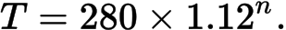
(i) Find the number of taxis in the city at the end of 2005.
(ii) Find the year in which the number of taxis is double the number of taxis there were at the end of 2000.
15b. [6 marks]
At the end of 2000 there were 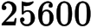 people in the city who used taxis.
After n years the number of people, P, in the city who used taxis is given by
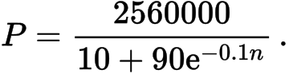
(i) Find the value of
P
at the end of 2005, giving your answer to the nearest whole number.
(ii) After seven complete years, will the value of P be double its value at the end of 2000? Justify your answer.
15c. [5 marks]
Let R be the ratio of the number of people using taxis in the city to the number of taxis. The city will reduce the number of taxis if 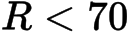 .
(i) Find the value of R at the end of 2000.
(ii) After how many complete years will the city first reduce the number of taxis?
16a. [1 mark]
The first three terms of an infinite geometric sequence are 32, 16 and 8.
Write down the value of r .
16b. [2 marks]
Find .
16c. [2 marks]
Find the sum to infinity of this sequence.
17. [6 marks]
In an arithmetic sequence, 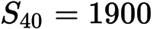 and 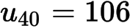 . Find the value of and of d .
18a. [3 marks]
In an arithmetic series, the first term is –7 and the sum of the first 20 terms is 620.
Find the common difference.
18b. [2 marks]
Find the value of the 78th term.
19a. [3 marks]
In a geometric series, 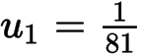 and 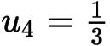.
Find the value of .
19b. [4 marks]
Find the smallest value of n for which 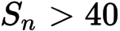 .
20a. [1 mark]
Expand 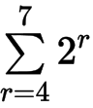 as the sum of four terms.
20b. [6 marks]
(i) Find the value of 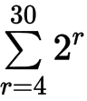 .
(ii) Explain why 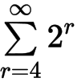 cannot be evaluated.
21a. [1 mark]
The n term of an arithmetic sequence is given by 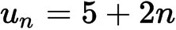 .
Write down the common difference.
21b. [5 marks]
(i) Given that the n term of this sequence is 115, find the value of n .
(ii) For this value of n , find the sum of the sequence.
22a. [1 mark]
Consider the arithmetic sequence 3, 9, 15, , 1353 .
Write down the common difference.
22b. [3 marks]
Find the number of terms in the sequence.
22c. [2 marks]
Find the sum of the sequence.
23a. [2 marks]
An arithmetic sequence, has 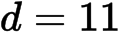 and 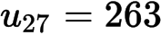 .
Find .
23b. [4 marks]
(i) Given that 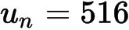 , find the value of n .
(ii) For this value of n , find 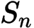 .
24a. [3 marks]
In an arithmetic series, the first term is −7 and the sum of the first 20 terms is 620.
Find the common difference.
24b. [2 marks]
Find the value of the 78 term.
25a. [3 marks]
In an arithmetic sequence 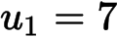 , 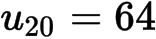 and 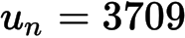 .
Find the value of the common difference.
25b. [2 marks]
Find the value of n .

Printed for British School of Beijing
© International Baccalaureate Organization 2015
International Baccalaureate® - Baccalauréat International® - Bachillerato Internacional®

Cp 6 Qs IB SL Maths
1a. [2 marks]

Markscheme
valid method (M1)
e.g. subtracting terms, using sequence formula
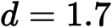A1 N2
[2 marks]
1b. [2 marks]

Markscheme
correct substitution into term formula (A1)
e.g. 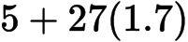
28 term is 50.9 (exact) A1 N2
[2 marks]
1c. [2 marks]

Markscheme
correct substitution into sum formula (A1)
e.g. 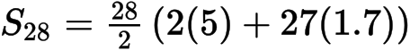 , 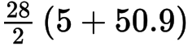
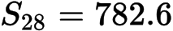 (exact) [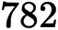, 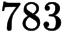] A1 N2
[2 marks]
2a. [4 marks]

Markscheme
correct substitution into sum of a geometric sequence (A1)
e.g. 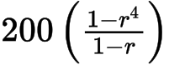 ,
attempt to set up an equation involving a sum and 324.8 M1
e.g. 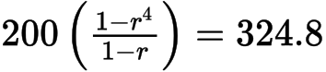 ,
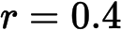 (exact) A2 N3
[4 marks]
2b. [2 marks]

Markscheme
correct substitution into formula A1
e.g. 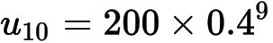
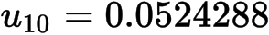 (exact), 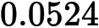A1 N1
[2 marks]
3a. [3 marks]
The first three terms of an arithmetic sequence are 36, 40, 44,….

Markscheme
(i) A1 N1
(ii) evidence of valid approach (M1)
e.g. 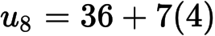 , repeated addition of d from 36
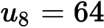A1 N2
[3 marks]
3b. [3 marks]

Markscheme
(i) correct substitution into sum formula A1
e.g. , 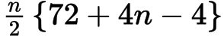
evidence of simplifying
e.g. 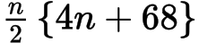 A1
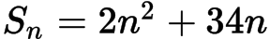AG N0
(ii) 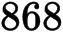A1 N1
[3 marks]
4a. [4 marks]

Markscheme
(i) correct approach (A1)
e.g. 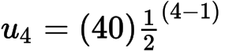, listing terms
A1 N2
(ii) correct substitution into formula for infinite sum (A1)
e.g. 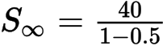 , 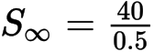
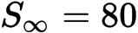A1 N2
[4 marks]
4b. [5 marks]

Markscheme
(i) attempt to set up expression for (M1)
e.g. 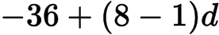
correct working A1
e.g. 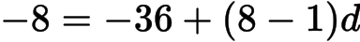 , 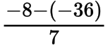
A1 N2
(ii) correct substitution into formula for sum (A1)
e.g.
correct working A1
e.g. 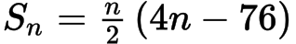 , 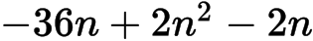
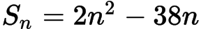AG N0
[5 marks]
4c. [5 marks]

Markscheme
multiplying 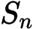 (AP) by 2 or dividing S (infinite GP) by 2 (M1)
e.g. 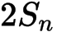 , 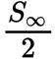 , 40
evidence of substituting into 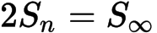A1
e.g. 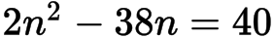 , 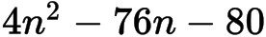 (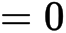)
attempt to solve their quadratic (equation) (M1)
e.g. intersection of graphs, formula
A2 N3
[5 marks]
5a. [2 marks]
In an arithmetic sequence, and 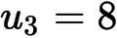 .

Markscheme
attempt to find d (M1)
e.g. 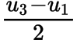 , 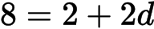
A1 N2
[2 marks]
5b. [2 marks]

Markscheme
correct substitution (A1)
e.g. 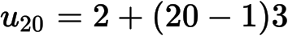 , 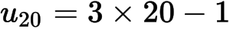
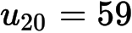A1 N2
[2 marks]
5c. [2 marks]

Markscheme
correct substitution (A1)
e.g. 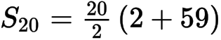 , 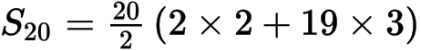
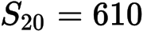A1 N2
[2 marks]
6a. [7 marks]
An arithmetic sequence is given by , , , ….

Markscheme
(a) A1 N1
[1 mark]
(b) (i) correct substitution into term formula (A1)
e.g. 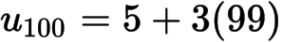 , 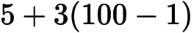
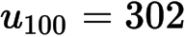A1 N2
(ii) correct substitution into sum formula (A1)
eg 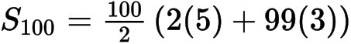 , 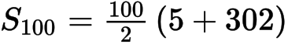
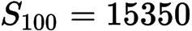A1 N2
[4 marks]
(c) correct substitution into term formula (A1)
eg 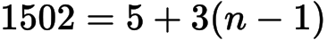 , 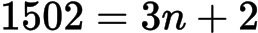
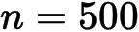A1 N2
[2 marks]
Total [7 marks]
6b. [1 mark]

Markscheme
A1 N1
[1 mark]
6c. [4 marks]

Markscheme
(i) correct substitution into term formula (A1)
e.g. ,
A1 N2
(ii) correct substitution into sum formula (A1)
eg ,
A1 N2
[4 marks]
6d. [2 marks]

Markscheme
correct substitution into term formula (A1)
eg ,
A1 N2
[2 marks]
Total [7 marks]
7. [6 marks]

Markscheme
correct substitution into sum of a geometric sequence A1
eg 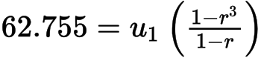 ,
correct substitution into sum to infinity A1
eg 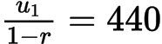
attempt to eliminate one variable (M1)
eg substituting 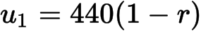
correct equation in one variable (A1)
eg 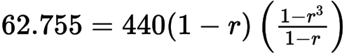 ,
evidence of attempting to solve the equation in a single variable (M1)
eg sketch, setting equation equal to zero, 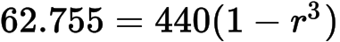
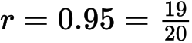A1 N4
[6 marks]
8a. [2 marks]
In an arithmetic sequence, the third term is 10 and the fifth term is 16.

Markscheme
attempt to find (M1)
eg
A1 N2
[2 marks]
8b. [2 marks]

Markscheme
correct approach (A1)
eg
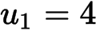A1 N2
[2 marks]
8c. [3 marks]

Markscheme
correct substitution into sum or term formula (A1)
eg
correct simplification (A1)
eg 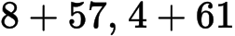
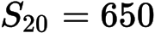A1 N2
[3 marks]
9a. [4 marks]
The sides of a square are 16 cm in length. The midpoints of the sides of this square are joined to form a new square and four triangles (diagram 1). The process is repeated twice, as shown in diagrams 2 and 3.
Let denote the length of one of the equal sides of each new triangle.
Let 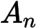 denote the area of each new triangle.

Markscheme
valid method for finding side length (M1)
eg
correct working for area (A1)
eg 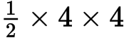
 | 1 | 2 | 3
 | 8 | 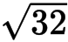 | 4
 | 32 | 16 | 8

A1A1 N2N2
[4 marks]
9b. [4 marks]

Markscheme
METHOD 1
recognize geometric progression for (R1)
eg 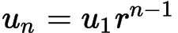
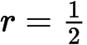 (A1)
correct working (A1)
eg 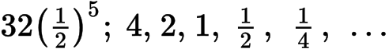
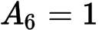A1 N3
METHOD 2
attempt to find (M1)
eg 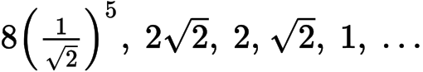
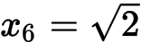(A1)
correct working (A1)
eg 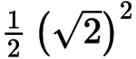
A1 N3
[4 marks]
9c. [7 marks]

Markscheme
METHOD 1
recognize infinite geometric series (R1)
eg 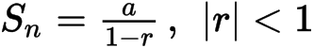
area of first triangle in terms of (A1)
eg 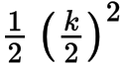
attempt to substitute into sum of infinite geometric series (must have ) (M1)
eg 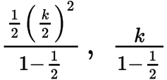
correct equation A1
eg 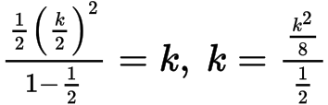
correct working (A1)
eg 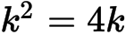
valid attempt to solve their quadratic (M1)
eg 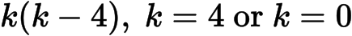
A1 N2
METHOD 2
recognizing that there are four sets of infinitely shaded regions with equal area R1
area of original square is 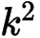(A1)
so total shaded area is 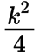(A1)
correct equation 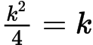A1
(A1)
valid attempt to solve their quadratic (M1)
eg
A1 N2
[7 marks]
10a. [4 marks]
The sums of the terms of a sequence follow the pattern

Markscheme
valid method (M1)
eg
A1A1A1 N4
[4 marks]
10b. [4 marks]

Markscheme
correct AP or GP (A1)
eg finding common difference is , common ratio is
valid approach using arithmetic and geometric formulas (M1)
eg 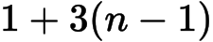and 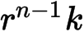
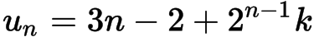A1A1 N4
Note: Award A1 for 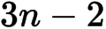, A1 for 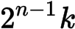.
[4 marks]
11a. [2 marks]
The first three terms of a infinite geometric sequence are 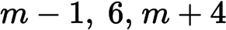, where 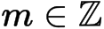.

Markscheme
correct expression for A1 N1
eg 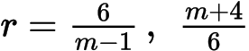
[2 marks]
11b. [2 marks]

Markscheme
correct equation A1
eg 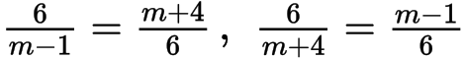
correct working (A1)
eg 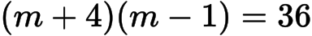
correct working A1
eg
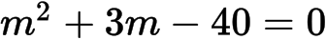AG N0
[2 marks]
11c. [3 marks]

Markscheme
valid attempt to solve (M1)
eg
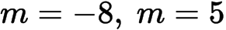A1A1 N3
[3 marks]
11d. [3 marks]

Markscheme
attempt to substitute any value of to find (M1)
eg 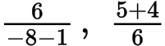
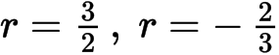A1A1 N3
[3 marks]
11e. [3 marks]

Markscheme
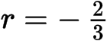 (may be seen in justification) A1
valid reason R1 N0
eg 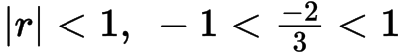
Notes: Award R1 for 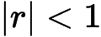 only if A1 awarded.
[2 marks]
11f. [3 marks]

Markscheme
finding the first term of the sequence which has (A1)
eg 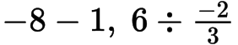
(may be seen in formula) (A1)
correct substitution of and their into 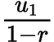, as long as A1
eg 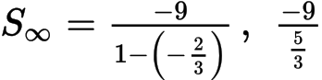
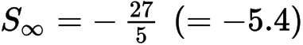A1 N3
[4 marks]
12a. [1 mark]

Markscheme
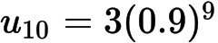A1 N1
[1 mark]
12b. [4 marks]

Markscheme
recognizing 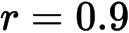(A1)
correct substitution A1
e.g. 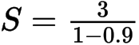
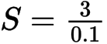(A1)
A1 N3
[4 marks]
13a. [3 marks]

Markscheme
(A1)
evidence of substitution into 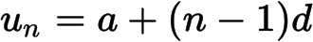(M1)
e.g. 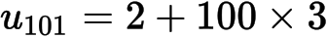
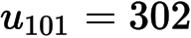A1 N3
[3 marks]
13b. [3 marks]

Markscheme
correct approach (M1)
e.g. 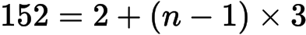
correct simplification (A1)
e.g. 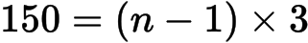 , 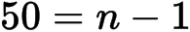 ,
A1 N2
[3 marks]
14a. [2 marks]
Consider the infinite geometric sequence .

Markscheme
evidence of dividing two terms (M1)
e.g. 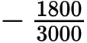 , 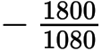
A1 N2
[2 marks]
14b. [2 marks]

Markscheme
evidence of substituting into the formula for the 10th term (M1)
e.g. 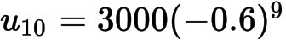
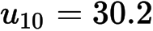 (accept the exact value 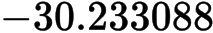) A1 N2
[2 marks]
14c. [2 marks]

Markscheme
evidence of substituting into the formula for the infinite sum (M1)
e.g. 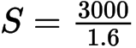
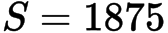A1 N2
[2 marks]
15a. [6 marks]
A city is concerned about pollution, and decides to look at the number of people using taxis. At the end of the year 2000, there were 280 taxis in the city. After n years the number of taxis, T, in the city is given by
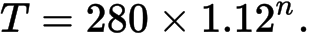

Markscheme
(i) (A1)
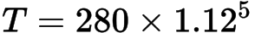
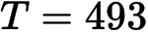A1 N2
(ii) evidence of doubling (A1)
e.g. 560
setting up equation A1
e.g. 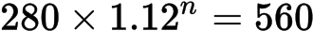, 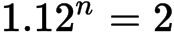
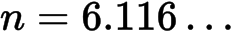 (A1)
in the year 2007 A1 N3
[6 marks]
15b. [6 marks]

Markscheme
(i) 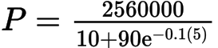(A1)
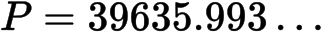(A1)
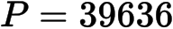A1 N3
(ii) 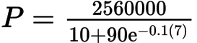
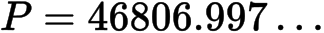A1
not doubled A1 N0
valid reason for their answer R1
e.g. 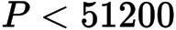
[6 marks]
15c. [5 marks]

Markscheme
(i) correct value A2 N2
e.g. 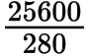 , 91.4, 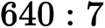
(ii) setting up an inequality (accept an equation, or reversed inequality) M1
e.g. 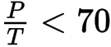 , 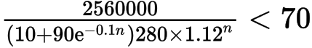
finding the value 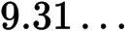 (A1)
after 10 years A1 N2
[5 marks]
16a. [1 mark]
The first three terms of an infinite geometric sequence are 32, 16 and 8.

Markscheme
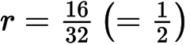A1 N1
[1 mark]
16b. [2 marks]

Markscheme
correct calculation or listing terms (A1)
e.g. 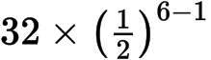 , 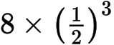 , 32, 4, 2, 1
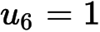A1 N2
[2 marks]
16c. [2 marks]

Markscheme
evidence of correct substitution in 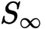A1
e.g. 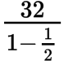 , 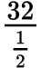
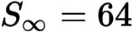 A1 N1
[2 marks]
17. [6 marks]

Markscheme
METHOD 1
substituting into formula for 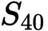 (M1)
correct substitution A1
e.g. 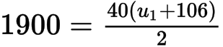
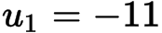A1 N2
substituting into formula for or (M1)
correct substitution A1
e.g. 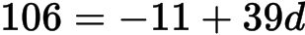 , 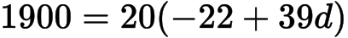
A1 N2
METHOD 2
substituting into formula for (M1)
correct substitution A1
e.g. 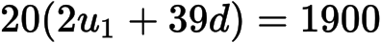
substituting into formula for (M1)
correct substitution A1
e.g. 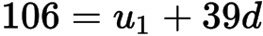
, A1A1 N2N2
[6 marks]
18a. [3 marks]
In an arithmetic series, the first term is –7 and the sum of the first 20 terms is 620.

Markscheme
attempt to substitute into sum formula for AP (accept term formula) (M1)
e.g. 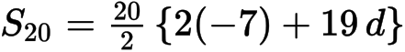 , 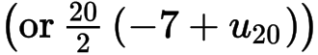
setting up correct equation using sum formula A1
e.g. 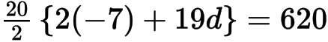
A1 N2
[3 marks]
18b. [2 marks]

Markscheme
correct substitution 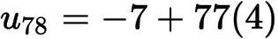(A1)
= 301 A1 N2
[2 marks]
19a. [3 marks]
In a geometric series, 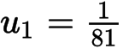 and 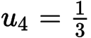.

Markscheme
evidence of substituting into formula for th term of GP (M1)
e.g. 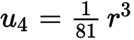
setting up correct equation 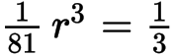A1
A1 N2
[3 marks]
19b. [4 marks]

Markscheme
METHOD 1
setting up an inequality (accept an equation) M1
e.g. 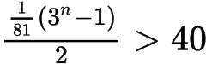 , 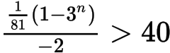 , 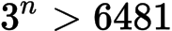
evidence of solving M1
e.g. graph, taking logs
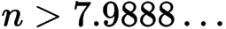(A1)
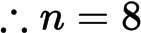A1 N2
METHOD 2
if , sum 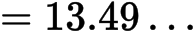 ; if , sum 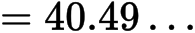A2
(is the smallest value) A2 N2
[4 marks]
20a. [1 mark]

Markscheme
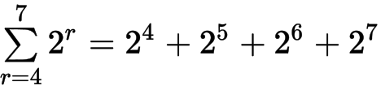 (accept ) A1 N1
[1 mark]
20b. [6 marks]

Markscheme
(i) METHOD 1
recognizing a GP (M1)
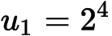 , , (A1)
correct substitution into formula for sum (A1)
e.g. 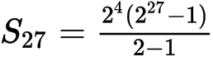
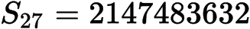A1 N4
METHOD 2
recognizing 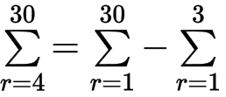(M1)
recognizing GP with , , (A1)
correct substitution into formula for sum
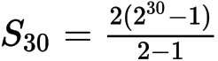(A1)
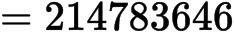
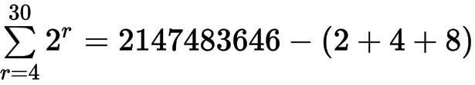
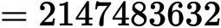 A1 N4
(ii) valid reason (e.g. infinite GP, diverging series), and 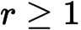 (accept 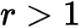 ) R1R1 N2
[6 marks]
21a. [1 mark]
The n term of an arithmetic sequence is given by 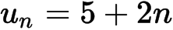 .

Markscheme
A1 N1
[1 mark]
21b. [5 marks]

Markscheme
(i) 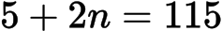(A1)
A1 N2
(ii) 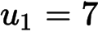 (may be seen in above) (A1)
correct substitution into formula for sum of arithmetic series (A1)
e.g. 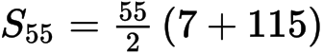 , 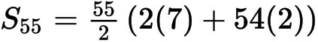 , 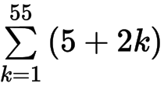
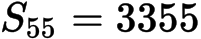(accept 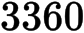) A1 N3
[5 marks]
22a. [1 mark]
Consider the arithmetic sequence 3, 9, 15, , 1353 .

Markscheme
common difference is 6 A1 N1
[1 mark]
22b. [3 marks]

Markscheme
evidence of appropriate approach (M1)
e.g. 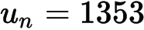
correct working A1
e.g. 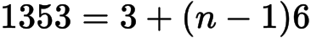 , 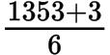
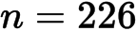A1 N2
[3 marks]
22c. [2 marks]

Markscheme
evidence of correct substitution A1
e.g. 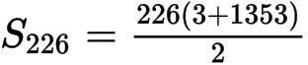 , 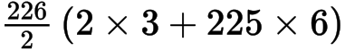
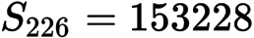 (accept 153000) A1 N1
[2 marks]
23a. [2 marks]
An arithmetic sequence, has 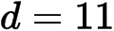 and 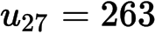 .

Markscheme
evidence of equation for M1
e.g. 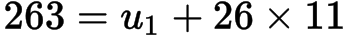 , 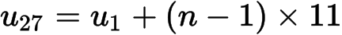 , 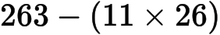
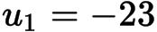A1 N1
[2 marks]
23b. [4 marks]

Markscheme
(i) correct equation A1
e.g. , 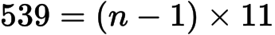
A1 N1
(ii) correct substitution into sum formula A1
e.g. 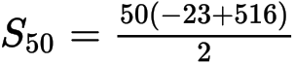 , 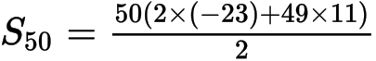
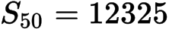 (accept 12300) A1 N1
[4 marks]
24a. [3 marks]
In an arithmetic series, the first term is −7 and the sum of the first 20 terms is 620.

Markscheme
attempt to substitute into sum formula for AP M1
e.g. 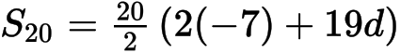 , 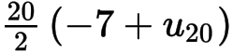
setting up correct equation using sum formula A1
e.g. 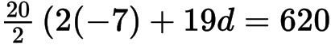
A1 N2
[3 marks]
24b. [2 marks]

Markscheme
correct substitution 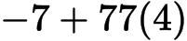A1
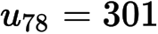A1 N2
[2 marks]
25a. [3 marks]
In an arithmetic sequence , 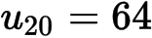 and 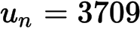 .

Markscheme
evidence of choosing the formula for 20th term (M1)
e.g. 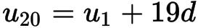
correct equation A1
e.g. 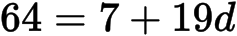 , 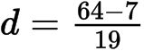
A1 N2
[3 marks]
25b. [2 marks]

Markscheme
correct substitution into formula for A1
e.g. 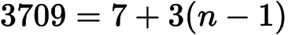 , 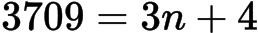
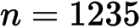A1 N1
[2 marks]

Printed for British School of Beijing
© International Baccalaureate Organization 2015
International Baccalaureate® - Baccalauréat International® - Bachillerato Internacional®

