Chp 7 IB SL Maths
1. [7 marks]
The third term in the expansion of 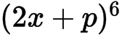is 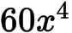. Find the possible values of p .
2a. [3 marks]
Expand 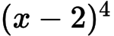 and simplify your result.
2b. [3 marks]
Find the term in 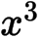 in 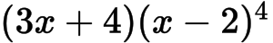 .
3. [5 marks]
Find the term in the expansion of 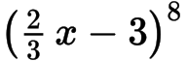 .
4a. [3 marks]
Consider the expansion of .
Find b.
4b. [3 marks]
Find k.
5a. [3 marks]
Expand 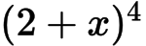 and simplify your result.
5b. [3 marks]
Hence, find the term in 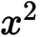 in 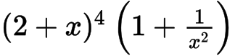 .
6a. [2 marks]
Let 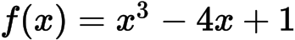 .
Expand 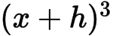 .
6b. [4 marks]
Use the formula 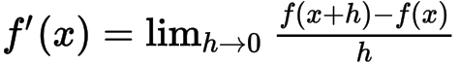to show that the derivative of 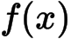 is 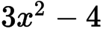 .
6c. [4 marks]
The tangent to the curve of f at the point 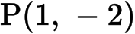 is parallel to the tangent at a point Q. Find the coordinates of Q.
6d. [3 marks]
The graph of f is decreasing for 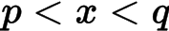 . Find the value of p and of q.
6e. [2 marks]
Write down the range of values for the gradient of .
7a. [1 mark]
The fifth term in the expansion of the binomial 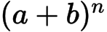 is given by 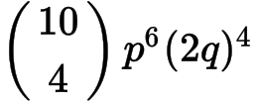 .
Write down the value of .
7b. [2 marks]
Write down a and b, in terms of p and/or q.
7c. [3 marks]
Write down an expression for the sixth term in the expansion.
8. [6 marks]
Find the term in 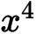 in the expansion of 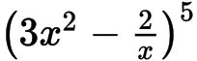 .
9a. [1 mark]
Consider the expansion of 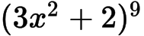 .
Write down the number of terms in the expansion.
9b. [5 marks]
Find the term in .
10a. [5 marks]
In the expansion of 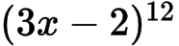 , the term in 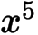 can be expressed as 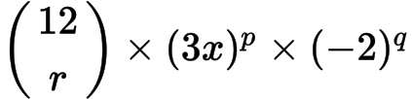 .
(a) Write down the value of , of and of .
(b) Find the coefficient of the term in .
10b. [3 marks]
Write down the value of , of and of .
10c. [2 marks]
Find the coefficient of the term in .
11. [7 marks]
The constant term in the expansion of 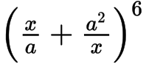 , where 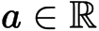 is 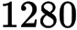. Find .
12a. [1 mark]
Consider the expansion of 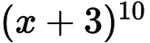.
Write down the number of terms in this expansion.
12b. [4 marks]
Find the term containing .
13. [7 marks]
Consider the expansion of 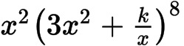. The constant term is 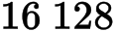.
Find .

Printed for British School of Beijing
© International Baccalaureate Organization 2015
International Baccalaureate® - Baccalauréat International® - Bachillerato Internacional®

Chp 7 IB SL Maths
1. [7 marks]

Markscheme
attempt to expand binomial (M1)
e.g. 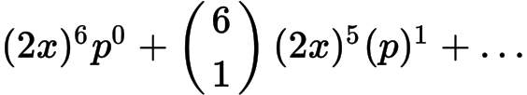 , 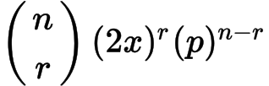
one correct calculation for term in 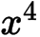 in the expansion for power 6 (A1)
e.g. 15 , 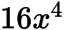
correct expression for term in (A1)
e.g. 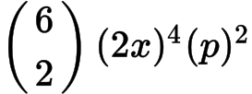 , 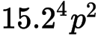
Notes: Accept sloppy notation e.g. omission of brackets around .
Accept absence of in middle factor.
correct term (A1)
e.g. 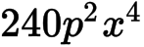 (accept absence of )
setting up equation with their coefficient equal to 60 M1
e.g. 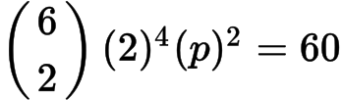 , 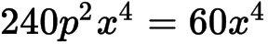 , 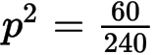
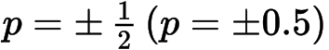A1A1 N3
[7 marks]
2a. [3 marks]

Markscheme
evidence of expanding M1
e.g. A2 N2
[3 marks]
2b. [3 marks]

Markscheme
finding coefficients, 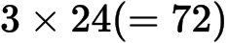 , 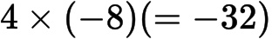(A1)(A1)
term is 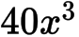A1 N3
[3 marks]
3. [5 marks]

Markscheme
evidence of using binomial expansion (M1)
e.g. selecting correct term, 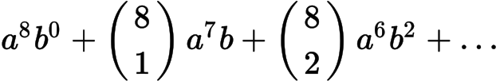
evidence of calculating the factors, in any order A1A1A1
e.g. 56 , 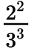 , 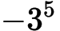 , 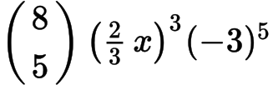
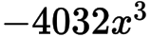 (accept = 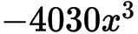 to 3 s.f.) A1 N2
[5 marks]
4a. [3 marks]
Consider the expansion of .

Markscheme
valid attempt to find term in 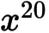(M1)
e.g. 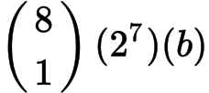 , 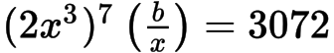
correct equation A1
e.g. 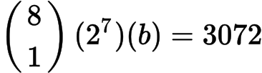
A1 N2
[3 marks]
4b. [3 marks]

Markscheme
evidence of choosing correct term (M1)
e.g. 7th term,
correct expression A1
e.g. 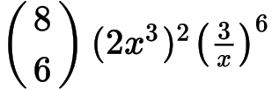
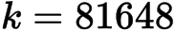 (accept ) A1 N2
[3 marks]
5a. [3 marks]

Markscheme
evidence of expanding M1
e.g. ,
A2 N2
[3 marks]
5b. [3 marks]

Markscheme
finding coefficients 24 and 1 (A1)(A1)
term is 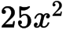A1 N3
[3 marks]
6a. [2 marks]
Let 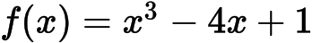 .

Markscheme
attempt to expand (M1)
A1 N2
[2 marks]
6b. [4 marks]

Markscheme
evidence of substituting 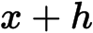(M1)
correct substitution A1
e.g. 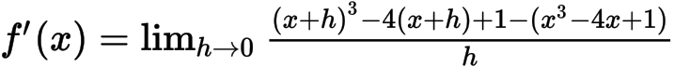
simplifying A1
e.g. 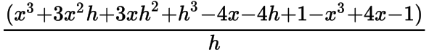
factoring out h A1
e.g. 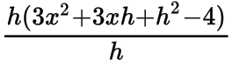
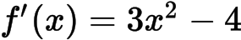AG N0
[4 marks]
6c. [4 marks]

Markscheme
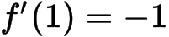(A1)
setting up an appropriate equation M1
e.g. 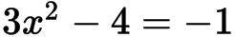
at Q, 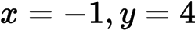 (Q is 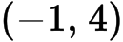) A1 A1
[4 marks]
6d. [3 marks]

Markscheme
recognizing that f is decreasing when 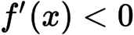R1
correct values for p and q (but do not accept 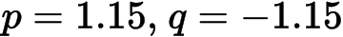 ) A1A1 N1N1
e.g. 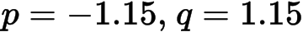 ; 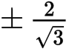 ; an interval such as 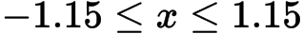
[3 marks]
6e. [2 marks]

Markscheme
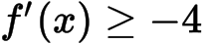 , 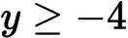 , 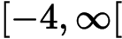A2 N2
[2 marks]
7a. [1 mark]
The fifth term in the expansion of the binomial 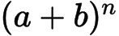 is given by 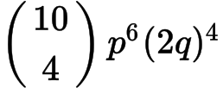 .

Markscheme
A1 N1
[1 mark]
7b. [2 marks]

Markscheme
, 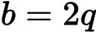 (or 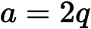 , 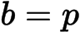 ) A1A1 N1N1
[2 marks]
7c. [3 marks]

Markscheme
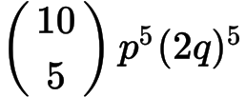 A1A1A1 N3
[3 marks]
8. [6 marks]

Markscheme
evidence of substituting into binomial expansion (M1)
e.g. 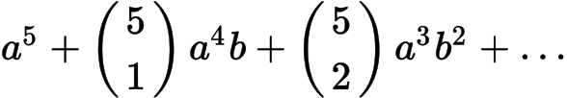
identifying correct term for (M1)
evidence of calculating the factors, in any order A1A1A1
e.g. 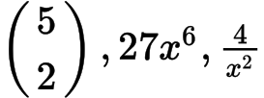 ; 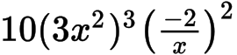
Note: Award A1 for each correct factor.
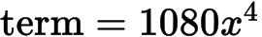A1 N2
Note: Award M1M1A1A1A1A0 for 1080 with working shown.
[6 marks]
9a. [1 mark]
Consider the expansion of 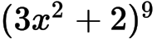 .

Markscheme
10 terms A1 N1
[1 mark]
9b. [5 marks]

Markscheme
evidence of binomial expansion (M1)
e.g. 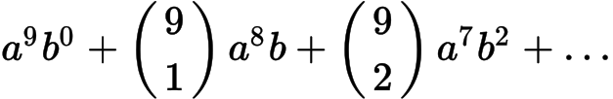, 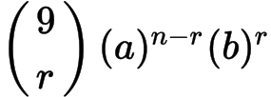, Pascal’s triangle
evidence of correct term (A1)
e.g. 8th term, , 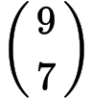 , 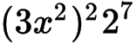
correct expression of complete term (A1)
e.g. 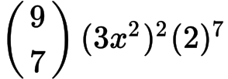 , 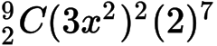 , 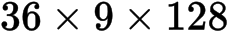
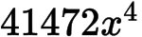 (accept 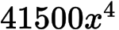 ) A1 N2
[4 marks]
10a. [5 marks]
In the expansion of 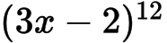 , the term in 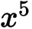 can be expressed as 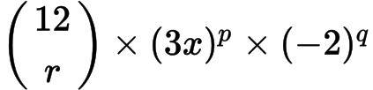 .

Markscheme
(a) 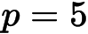 , 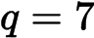 , (accept ) A1A1A1 N3
[3 marks]
(b) correct working (A1)
eg 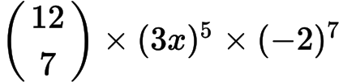 , 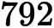 , 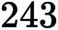 , 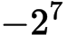 , 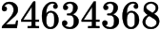
coefficient of term in is 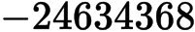A1 N2
Note: Do not award the final A1 for an answer that contains .
[2 marks]
Total [5 marks]
10b. [3 marks]

Markscheme
, , (accept ) A1A1A1 N3
[3 marks]
10c. [2 marks]

Markscheme
correct working (A1)
eg , , , ,
coefficient of term in is A1 N2
Note: Do not award the final A1 for an answer that contains .
[2 marks]
Total [5 marks]
11. [7 marks]

Markscheme
evidence of binomial expansion (M1)
eg selecting correct term,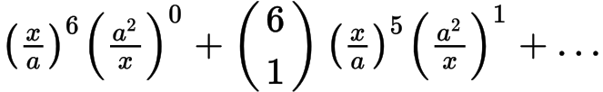
evidence of identifying constant term in expansion for power (A1)
eg , 4 term
evidence of correct term (may be seen in equation) A2
eg 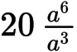 , 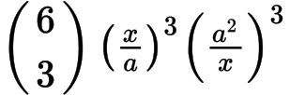
attempt to set up their equation (M1)
eg 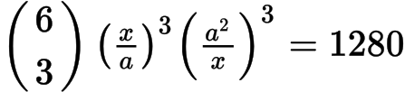, 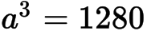
correct equation in one variable (A1)
eg , 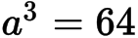
A1 N4
[7 marks]
12a. [1 mark]
Consider the expansion of 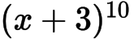.

Markscheme
11 terms A1 N1
[1 mark]
12b. [4 marks]

Markscheme
evidence of binomial expansion (M1)
eg 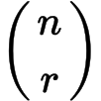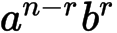, attempt to expand
evidence of choosing correct term (A1)
eg 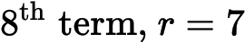, 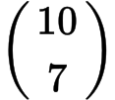, 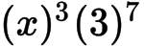
correct working (A1)
eg , 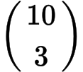,
A1 N3
[4 marks]
13. [7 marks]

Markscheme
valid approach (M1)
eg 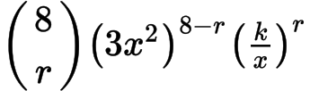,
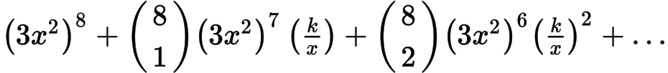, Pascal’s triangle to 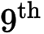 line
attempt to find value of r which gives term in 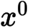(M1)
eg exponent in binomial must give 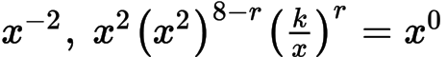
correct working (A1)
eg
evidence of correct term (A1)
eg 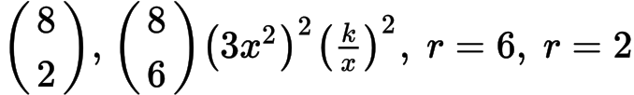
equating their term and 16128 to solve for M1
eg 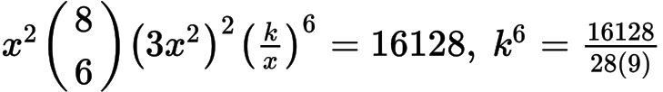
A1A1 N2
Note: If no working shown, award N0 for .
Total [7 marks]

Printed for British School of Beijing
© International Baccalaureate Organization 2015
International Baccalaureate® - Baccalauréat International® - Bachillerato Internacional®

