Chp 9 IB SL maths Qs ms
Note there are a couple of circle Qs & Radians Qs that you can ignore at the moment. Will delete them one day.
1a. [1 mark]
The following diagram shows 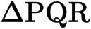 , where RQ = 9 cm, 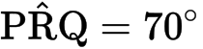 and 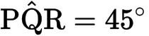 .
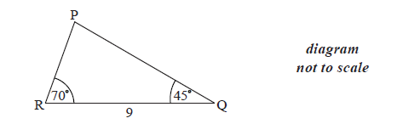
Find 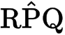 .
1b. [3 marks]
Find PR .
1c. [2 marks]
Find the area of 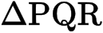 .
2a. [4 marks]
The following diagram shows a triangle ABC.
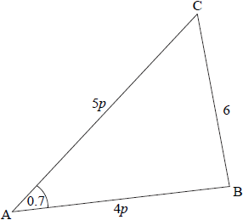
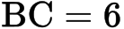 , 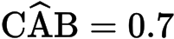 radians , 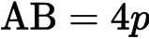 , 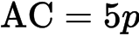 , where 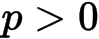 .
(i) Show that 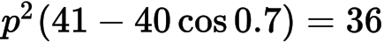 .
(ii) Find p .
2b. [1 mark]
Consider the circle with centre B that passes through the point C. The circle cuts the line CA at D, and is obtuse. Part of the circle is shown in the following diagram.
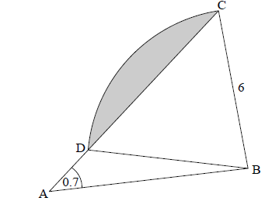
Write down the length of BD.
2c. [4 marks]
Find .
2d. [6 marks]
(i) Show that radians, correct to 2 decimal places.
(ii) Hence, find the area of the shaded region.
3a. [3 marks]
The diagram shows a circle of radius metres. The points ABCD lie on the circumference of the circle.
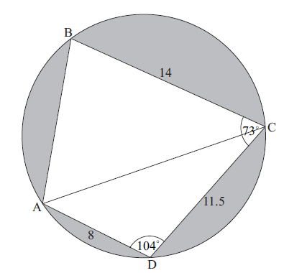
BC = m, CD = 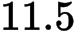 m, AD = m, 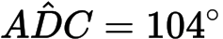 , and 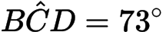 .
Find AC.
3b. [5 marks]
(i) Find .
(ii) Hence, find .
3c. [2 marks]
Find the area of triangle ADC.
3d. [6 marks]
(c) Find the area of triangle ADC.
(d) Hence or otherwise, find the total area of the shaded regions.
3e. [4 marks]
Hence or otherwise, find the total area of the shaded regions.
4a. [3 marks]
The following diagram shows a triangle ABC.
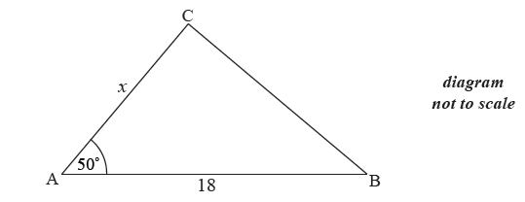
The area of triangle ABC is 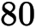 cm , AB 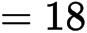 cm , AC cm and 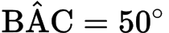 .
Find .
4b. [3 marks]
Find BC.
5a. [3 marks]
The following diagram shows triangle ABC.
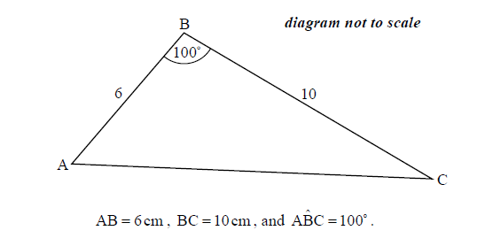
Find AC.
5b. [3 marks]
Find .
6a. [4 marks]
In triangle , and . The area of the triangle is 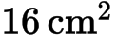.
Find the two possible values for 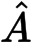.
6b. [3 marks]
Given that is obtuse, find .
7a. [3 marks]
Consider a circle with centre and radius cm. Triangle is drawn such that its vertices are on the circumference of the circle.
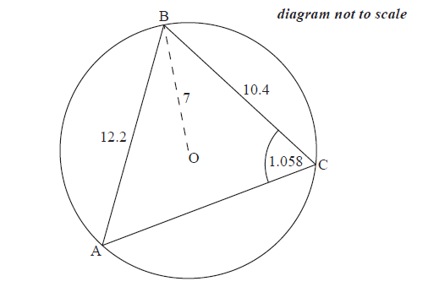
cm, cm and 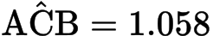 radians.
Find .
7b. [5 marks]
Find .
7c. [6 marks]
Hence or otherwise, find the length of arc .
8a. [4 marks]
A ship leaves port A on a bearing of 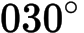 . It sails a distance of 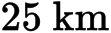 to point B. At B, the ship changes direction to a bearing of 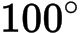 . It sails a distance of to reach point C. This information is shown in the diagram below.
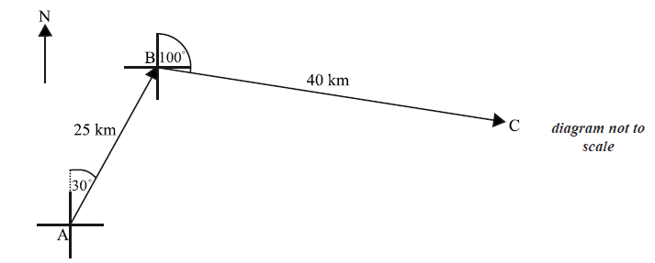
A second ship leaves port A and sails directly to C.
Find the distance the second ship will travel.
8b. [3 marks]
Find the bearing of the course taken by the second ship.
9a. [5 marks]
The diagram shows a parallelogram ABCD.
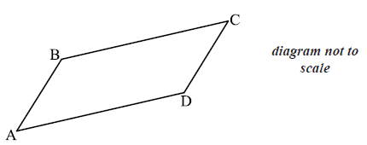
The coordinates of A, B and D are A(1, 2, 3) , B(6, 4,4 ) and D(2, 5, 5) .
(i) Show that 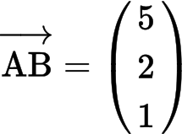 .
(ii) Find 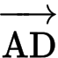 .
(iii) Hence show that 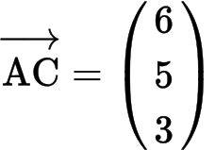 .
9b. [3 marks]
Find the coordinates of point C.
9c. [7 marks]
(i) Find 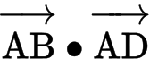.
(ii) Hence find angle A.
9d. [3 marks]
Hence, or otherwise, find the area of the parallelogram.
10a. [3 marks]
The diagram below shows triangle PQR. The length of [PQ] is 7 cm , the length of [PR] is 10 cm , and 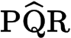 is 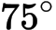 .
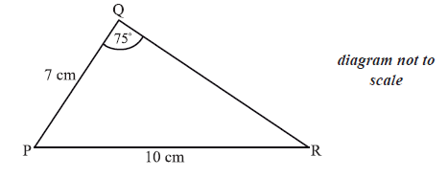
Find 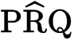 .
10b. [3 marks]
Find the area of triangle PQR.
11a. [3 marks]
The vertices of the triangle PQR are defined by the position vectors
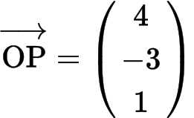 , 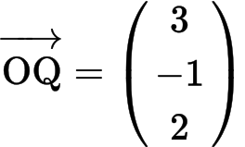 and 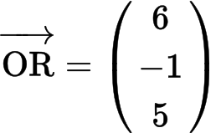 .
Find
(i) 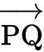;
(ii) .
11b. [7 marks]
Show that 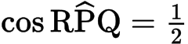 .
11c. [6 marks]
(i) Find 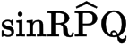 .
(ii) Hence, find the area of triangle PQR, giving your answer in the form 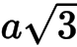 .
12a. [3 marks]
The diagram below shows a triangle ABD with AB =13 cm and AD = 6.5 cm.
Let C be a point on the line BD such that BC = AC = 7 cm.
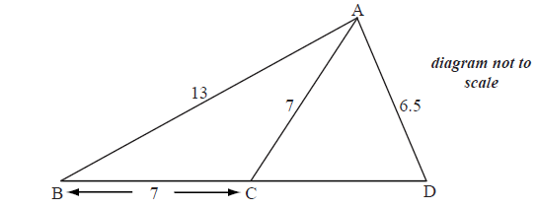
Find the size of angle ACB.
12b. [5 marks]
Find the size of angle CAD.
13a. [4 marks]
The following diagram shows the triangle ABC.
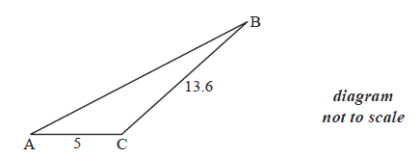
The angle at C is obtuse, , and the area is 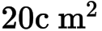 .
Find .
13b. [3 marks]
Find AB.
14a. [1 mark]
The diagram below shows a quadrilateral ABCD with obtuse angles 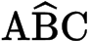 and 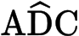.
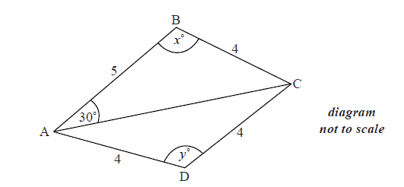
AB = 5 cm, BC = 4 cm, CD = 4 cm, AD = 4 cm , 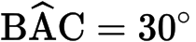 , 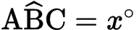 , 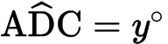 .
Use the cosine rule to show that 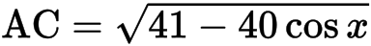 .
14b. [2 marks]
Use the sine rule in triangle ABC to find another expression for AC.
14c. [6 marks]
(i) Hence, find x, giving your answer to two decimal places.
(ii) Find AC .
14d. [5 marks]
(i) Find y.
(ii) Hence, or otherwise, find the area of triangle ACD.
15a. [2 marks]
The diagram below shows a circle with centre O and radius 8 cm.
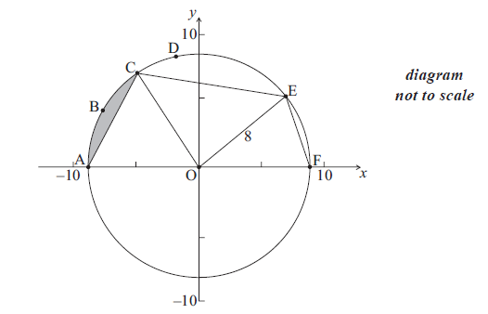
The points A, B, C, D, E and F are on the circle, and [AF] is a diameter. The length of arc ABC is 6 cm.
Find the size of angle AOC .
15b. [6 marks]
Hence find the area of the shaded region.
15c. [2 marks]
The area of sector OCDE is 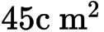.
Find the size of angle COE .
15d. [5 marks]
Find EF .
16a. [4 marks]
Consider the triangle ABC, where AB =10 , BC = 7 and = 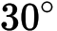 .
Find the two possible values of .
16b. [2 marks]
Hence, find , given that it is acute.
17a. [3 marks]
The following diagram shows triangle ABC .
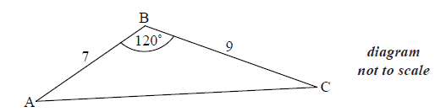
AB = 7 cm, BC = 9 cm and 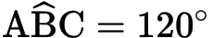 .
Find AC .
17b. [3 marks]
Find .
18a. [3 marks]
There is a vertical tower TA of height 36 m at the base A of a hill. A straight path goes up the hill from A to a point U. This information is represented by the following diagram.
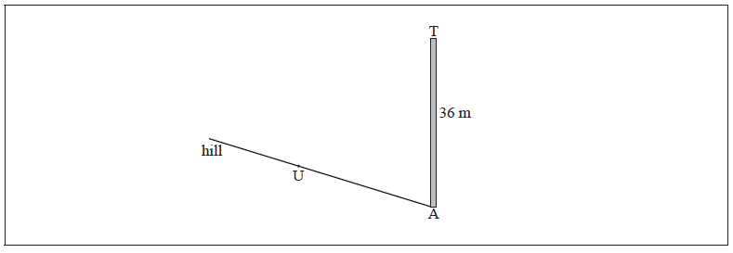
The path makes a 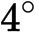 angle with the horizontal.
The point U on the path is 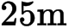 away from the base of the tower.
The top of the tower is fixed to U by a wire of length .
Complete the diagram, showing clearly all the information above.
18b. [4 marks]
Find x .
19. [7 marks]
The following diagram shows a pole BT 1.6 m tall on the roof of a vertical building.
The angle of depression from T to a point A on the horizontal ground is 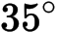 .
The angle of elevation of the top of the building from A is 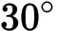 .
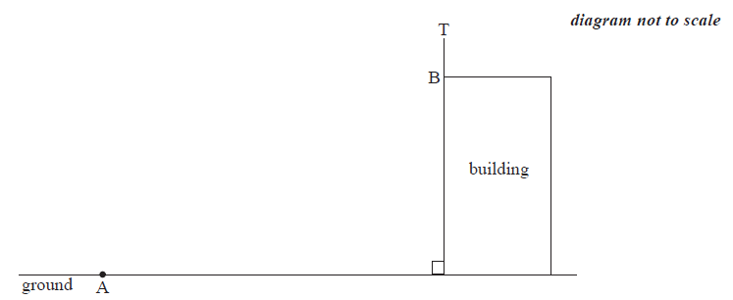
Find the height of the building.

Printed for British School of Beijing
© International Baccalaureate Organization 2015
International Baccalaureate® - Baccalauréat International® - Bachillerato Internacional®

Chp 9 IB SL maths Qs ms
1a. [1 mark]
The following diagram shows 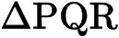 , where RQ = 9 cm, 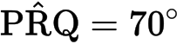 and 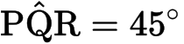 .

Markscheme
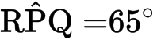A1 N1
[1 mark]
1b. [3 marks]

Markscheme
evidence of choosing sine rule (M1)
correct substitution A1
e.g. 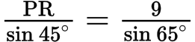
7.021854078
A1 N2
[3 marks]
1c. [2 marks]

Markscheme
correct substitution (A1)
e.g.
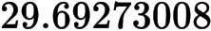
A1 N2
[2 marks]
2a. [4 marks]
The following diagram shows a triangle ABC.
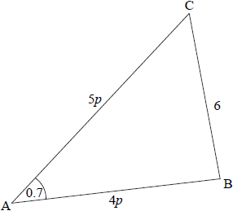
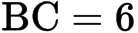 , 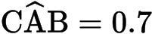 radians , 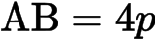 , 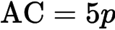 , where 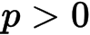 .

Markscheme
(i) evidence of valid approach (M1)
e.g. choosing cosine rule
correct substitution (A1)
e.g.
simplification A1
e.g.
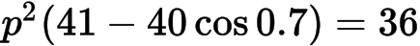AG N0
(ii)
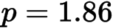A1 N1
Note: Award A0 for 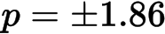 , i.e. not rejecting the negative value.
[4 marks]
2b. [1 mark]
Consider the circle with centre B that passes through the point C. The circle cuts the line CA at D, and is obtuse. Part of the circle is shown in the following diagram.

Markscheme
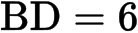A1 N1
[1 mark]
2c. [4 marks]

Markscheme
evidence of valid approach (M1)
e.g. choosing sine rule
correct substitution A1
e.g. 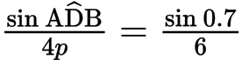
(A1)
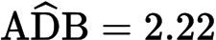A1 N3
[4 marks]
2d. [6 marks]

Markscheme
(i) evidence of valid approach (M1)
e.g. recognize isosceles triangle, base angles equal
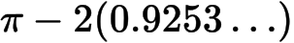A1
AG N0
(ii) area of sector BCD (A1)
e.g. 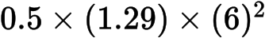
area of triangle BCD (A1)
e.g. 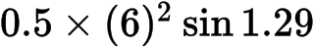
evidence of subtraction M1
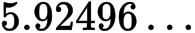
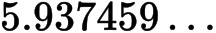
A1 N3
[6 marks]
3a. [3 marks]
The diagram shows a circle of radius metres. The points ABCD lie on the circumference of the circle.
BC = m, CD = 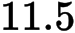 m, AD = m, 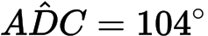 , and 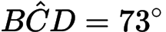 .

Markscheme
evidence of choosing cosine rule (M1)
eg ,
correct substitution A1
eg ,
AC 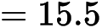 (m) A1 N2
[3 marks]
3b. [5 marks]

Markscheme
(i) METHOD 1
evidence of choosing sine rule (M1)
eg 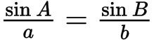 , 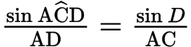
correct substitution A1
eg 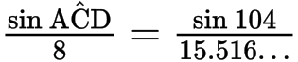
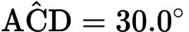A1 N2
METHOD 2
evidence of choosing cosine rule (M1)
eg
correct substitution A1
e.g.
A1 N2
(ii) subtracting their from 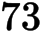 (M1)
eg 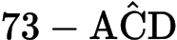 , 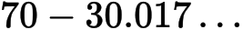
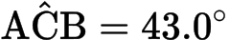A1 N2
[5 marks]
3c. [2 marks]

Markscheme
correct substitution (A1)
eg area 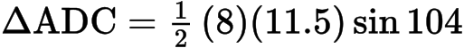
area 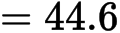 (m) A1 N2
[2 marks]
3d. [6 marks]

Markscheme
(c) correct substitution (A1)
eg area
area (m) A1 N2
[2 marks]
(d) attempt to subtract (M1)
eg ,
area (A1)
correct working A1
eg , 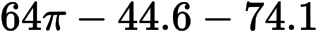
shaded area is 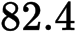 (m) A1 N3
[4 marks]
Total [6 marks]
3e. [4 marks]

Markscheme
attempt to subtract (M1)
eg ,
area (A1)
correct working A1
eg , 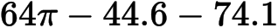
shaded area is 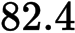 (m) A1 N3
[4 marks]
Total [6 marks]
4a. [3 marks]
The following diagram shows a triangle ABC.
The area of triangle ABC is 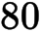 cm , AB 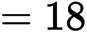 cm , AC cm and 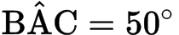 .

Markscheme
correct substitution into area formula (A1)
eg 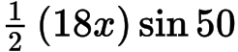
setting their area expression equal to (M1)
eg 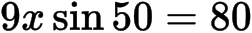
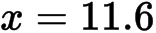A1 N2
[3 marks]
4b. [3 marks]

Markscheme
evidence of choosing cosine rule (M1)
eg
correct substitution into right hand side (may be in terms of ) (A1)
eg
BC 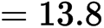A1 N2
[3 marks]
5a. [3 marks]
The following diagram shows triangle ABC.

Markscheme
evidence of choosing cosine rule (M1)
eg
correct substitution into the right-hand side (A1)
eg 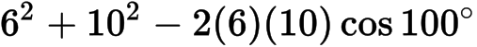
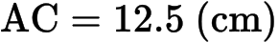A1 N2
[3 marks]
5b. [3 marks]

Markscheme
evidence of choosing a valid approach (M1)
eg sine rule, cosine rule
correct substitution (A1)
eg 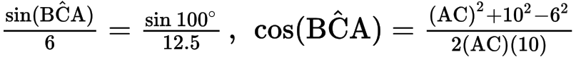
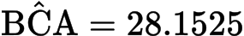
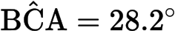A1 N2
[3 marks]
6a. [4 marks]
In triangle , and . The area of the triangle is 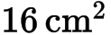.

Markscheme
correct substitution into area formula (A1)
eg 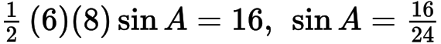
correct working (A1)
eg 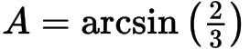
;
; A1A1 N3
(accept degrees ie 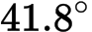; 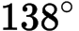)
[4 marks]
6b. [3 marks]

Markscheme
evidence of choosing cosine rule (M1)
eg
correct substitution into RHS (angle must be obtuse) (A1)
eg ,
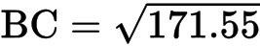
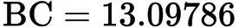
A1 N2
[3 marks]
7a. [3 marks]
Consider a circle with centre and radius cm. Triangle is drawn such that its vertices are on the circumference of the circle.
cm, cm and 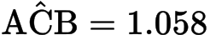 radians.

Markscheme
Notes: In this question, there may be slight differences in answers, depending on which values candidates carry through in subsequent parts. Accept answers that are consistent with their working.
Candidates may have their GDCs in degree mode, leading to incorrect answers. If working shown, award marks in line with the markscheme, with FT as appropriate.
Ignore missing or incorrect units.
evidence of choosing sine rule (M1)
eg 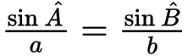
correct substitution (A1)
eg 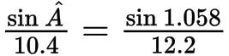
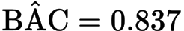A1 N2
[3 marks]
7b. [5 marks]

Markscheme
Notes: In this question, there may be slight differences in answers, depending on which values candidates carry through in subsequent parts. Accept answers that are consistent with their working.
Candidates may have their GDCs in degree mode, leading to incorrect answers. If working shown, award marks in line with the markscheme, with FT as appropriate.
Ignore missing or incorrect units.
METHOD 1
evidence of subtracting angles from (M1)
eg
correct angle (seen anywhere) A1
attempt to substitute into cosine or sine rule (M1)
correct substitution (A1)
eg
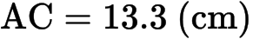A1 N3
METHOD 2
evidence of choosing cosine rule M1
eg
correct substitution (A2)
eg
A2 N3
[5 marks]
7c. [6 marks]

Markscheme
Notes: In this question, there may be slight differences in answers, depending on which values candidates carry through in subsequent parts. Accept answers that are consistent with their working.
Candidates may have their GDCs in degree mode, leading to incorrect answers. If working shown, award marks in line with the markscheme, with FT as appropriate.
Ignore missing or incorrect units.
METHOD 1
valid approach (M1)
eg 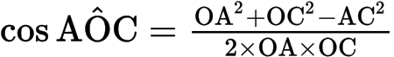,
correct working (A1)
eg
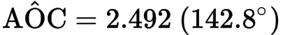(A1)
EITHER
correct substitution for arc length (seen anywhere) A1
eg
subtracting arc from circumference (M1)
eg 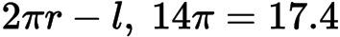
OR
attempt to find reflex (M1)
eg
correct substitution for arc length (seen anywhere) A1
eg 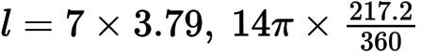
THEN
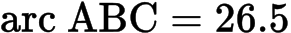A1 N4
METHOD 2
valid approach to find or (M1)
eg choosing cos rule, twice angle at circumference
correct working for finding one value, or (A1)
eg 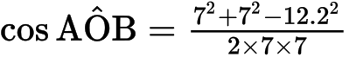,
two correct calculations for arc lengths
eg (A1)(A1)
adding their arc lengths (seen anywhere)
eg M1
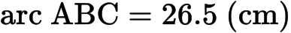A1 N4
Note: Candidates may work with other interior triangles using a similar method. Check calculations carefully and award marks in line with markscheme.
[6 marks]
8a. [4 marks]
A ship leaves port A on a bearing of 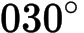 . It sails a distance of 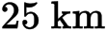 to point B. At B, the ship changes direction to a bearing of 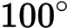 . It sails a distance of to reach point C. This information is shown in the diagram below.
A second ship leaves port A and sails directly to C.

Markscheme
finding 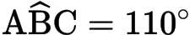 (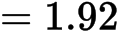 radians) (A1)
evidence of choosing cosine rule (M1)
e.g.
correct substitution A1
e.g.
(km) A1
8b. [3 marks]

Markscheme
METHOD 1
correct substitution into the sine rule A1
e.g. 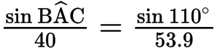A1
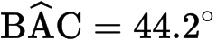
bearing 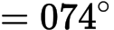A1 N1
METHOD 2
correct substitution into the cosine rule A1
e.g. 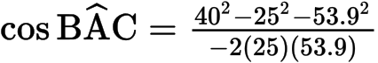A1
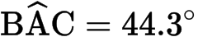
bearing A1 N1
[3 marks]
9a. [5 marks]
The diagram shows a parallelogram ABCD.
The coordinates of A, B and D are A(1, 2, 3) , B(6, 4,4 ) and D(2, 5, 5) .

Markscheme
(i) evidence of approach M1
e.g. , 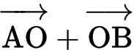 , 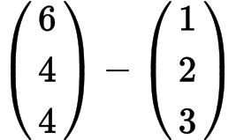
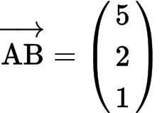AG N0
(ii) evidence of approach (M1)
e.g. , 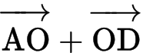 , 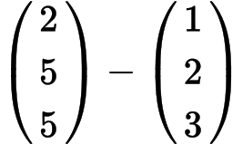
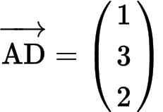 A1 N2
(iii) evidence of approach (M1)
e.g. 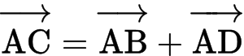
correct substitution A1
e.g. 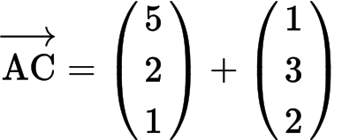
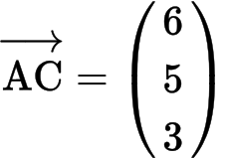AG N0
[5 marks]
9b. [3 marks]

Markscheme
evidence of combining vectors (there are at least 5 ways) (M1)
e.g. 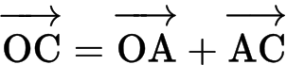 , 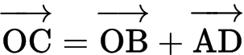, 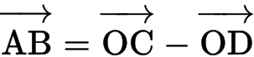
correct substitution A1
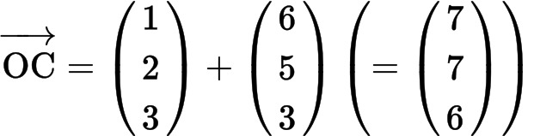
e.g. coordinates of C are 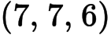A1 N1
[3 marks]
9c. [7 marks]

Markscheme
(i) evidence of using scalar product on 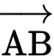 and 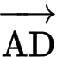(M1)
e.g. 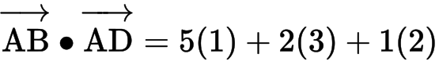
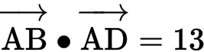A1 N2
(ii) 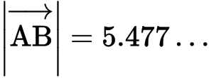 , 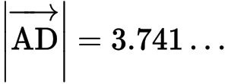(A1)(A1)
evidence of using 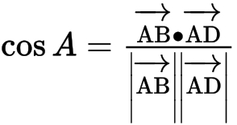(M1)
correct substitution A1
e.g. 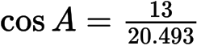
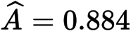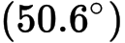A1 N3
[7 marks]
9d. [3 marks]

Markscheme
METHOD 1
evidence of using 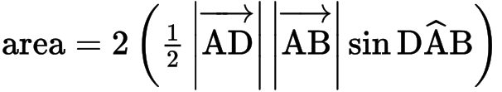 (M1)
correct substitution A1
e.g.
A1 N2
METHOD 2
evidence of using (M1)
finding height of parallelogram A1
e.g. ,
A1 N2
[3 marks]
10a. [3 marks]
The diagram below shows triangle PQR. The length of [PQ] is 7 cm , the length of [PR] is 10 cm , and 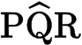 is 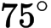 .

Markscheme
choosing sine rule (M1)
correct substitution 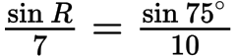A1
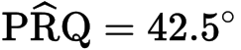A1 N2
[3 marks]
10b. [3 marks]

Markscheme
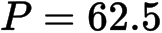(A1)
substitution into any correct formula A1
e.g.
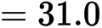 (cm) A1 N2
[3 marks]
11a. [3 marks]
The vertices of the triangle PQR are defined by the position vectors
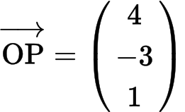 , 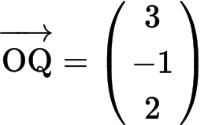 and 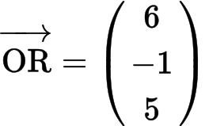 .

Markscheme
(i) evidence of approach (M1)
e.g. 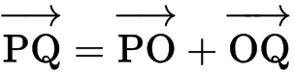 ,
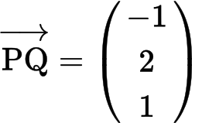A1 N2
(ii) 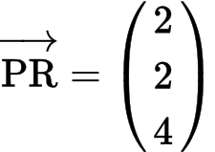A1 N1
[3 marks]
11b. [7 marks]

Markscheme
METHOD 1
choosing correct vectors 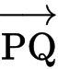 and (A1)(A1)
finding 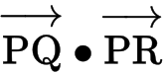 , 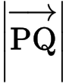 , (A1) (A1)(A1)
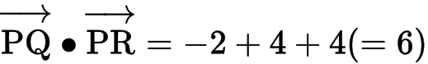
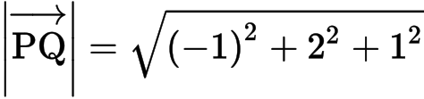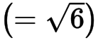 , 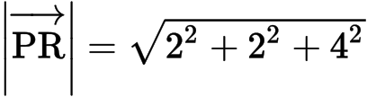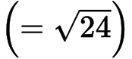
substituting into formula for angle between two vectors M1
e.g. 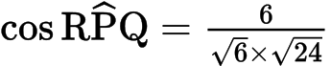
simplifying to expression clearly leading to A1
e.g. 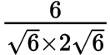 , 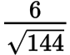 , 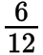
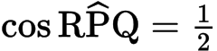 AG N0
METHOD 2
evidence of choosing cosine rule (seen anywhere) (M1)
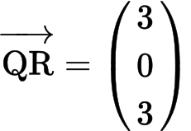A1
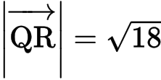 , 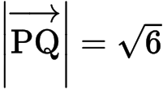 and 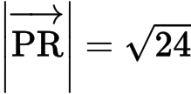(A1)(A1)(A1)
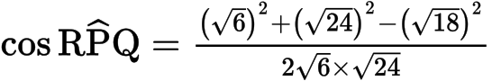A1
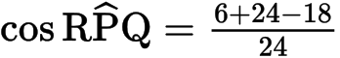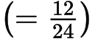A1
AG N0
[7 marks]
11c. [6 marks]

Markscheme
(i) METHOD 1
evidence of appropriate approach (M1)
e.g. using 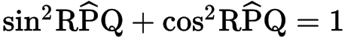 , diagram
substituting correctly (A1)
e.g. 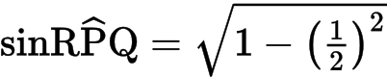
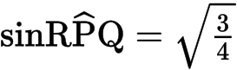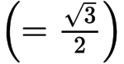A1 N3
METHOD 2
since 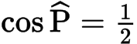 , 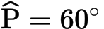(A1)
evidence of approach
e.g. drawing a right triangle, finding the missing side (A1)
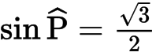A1 N3
(ii) evidence of appropriate approach (M1)
e.g. attempt to substitute into 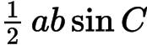
correct substitution
e.g. area 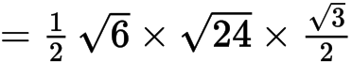A1
area 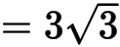 A1 N2
[6 marks]
12a. [3 marks]
The diagram below shows a triangle ABD with AB =13 cm and AD = 6.5 cm.
Let C be a point on the line BD such that BC = AC = 7 cm.

Markscheme
METHOD 1
evidence of choosing the cosine formula (M1)
correct substitution A1
e.g. 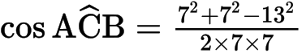
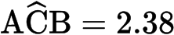 radians 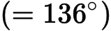A1 N2
METHOD 2
evidence of appropriate approach involving right-angled triangles (M1)
correct substitution A1
e.g. 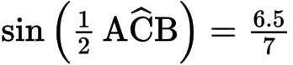
radians A1 N2
[3 marks]
12b. [5 marks]

Markscheme
METHOD 1
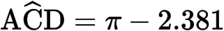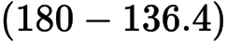 (A1)
evidence of choosing the sine rule in triangle ACD (M1)
correct substitution A1
e.g. 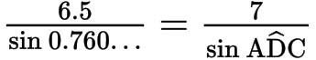
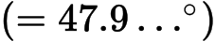A1
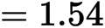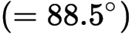A1 N3
METHOD 2
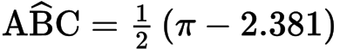 (A1)
evidence of choosing the sine rule in triangle ABD (M1)
correct substitution A1
e.g. 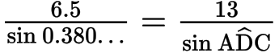
A1
A1 N3
Note: Two triangles are possible with the given information. If candidate finds 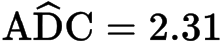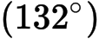 leading to 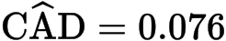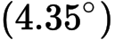 , award marks as per markscheme.
[5 marks]
13a. [4 marks]
The following diagram shows the triangle ABC.
The angle at C is obtuse, , and the area is 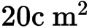 .

Markscheme
correct substitution into the formula for the area of a triangle A1
e.g. 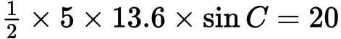 , 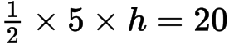
attempt to solve (M1)
e.g. , 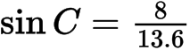
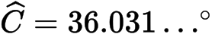() (A1)
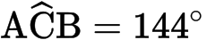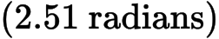A1 N3
[4 marks]
13b. [3 marks]

Markscheme
evidence of choosing the cosine rule (M1)
correct substitution A1
e.g.
A1 N2
[3 marks]
14a. [1 mark]
The diagram below shows a quadrilateral ABCD with obtuse angles 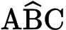 and 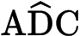.
AB = 5 cm, BC = 4 cm, CD = 4 cm, AD = 4 cm , 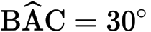 , 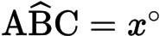 , 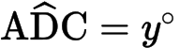 .

Markscheme
correct substitution A1
e.g. ,
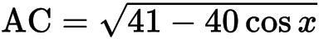AG
[1 mark]
14b. [2 marks]

Markscheme
correct substitution A1
e.g. 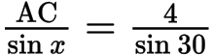 , 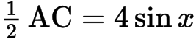
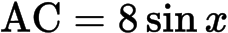 (accept 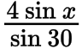) A1 N1
[2 marks]
14c. [6 marks]

Markscheme
(i) evidence of appropriate approach using AC M1
e.g. 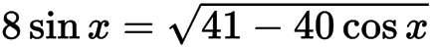 , sketch showing intersection
correct solution 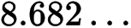, 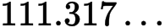(A1)
obtuse value (A1)
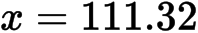 to 2 dp (do not accept the radian answer 1.94 ) A1 N2
(ii) substituting value of x into either expression for AC (M1)
e.g. 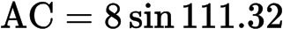
A1 N2
[6 marks]
14d. [5 marks]

Markscheme
(i) evidence of choosing cosine rule (M1)
e.g. 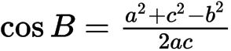
correct substitution A1
e.g. 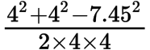 , 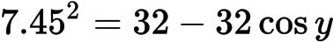 ,
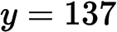A1 N2
(ii) correct substitution into area formula (A1)
e.g. 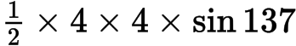 , 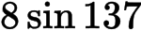
area 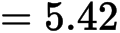A1 N2
[5 marks]
15a. [2 marks]
The diagram below shows a circle with centre O and radius 8 cm.
The points A, B, C, D, E and F are on the circle, and [AF] is a diameter. The length of arc ABC is 6 cm.

Markscheme
appropriate approach (M1)
e.g. 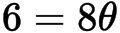
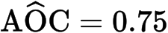A1 N2
[2 marks]
15b. [6 marks]

Markscheme
evidence of substitution into formula for area of triangle (M1)
e.g. 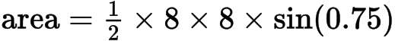
area 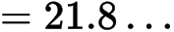(A1)
evidence of substitution into formula for area of sector (M1)
e.g. 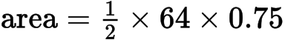
area of sector (A1)
evidence of substituting areas (M1)
e.g. 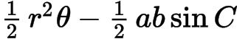,
area of shaded region 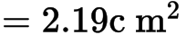A1 N4
[6 marks]
15c. [2 marks]

Markscheme
attempt to set up an equation for area of sector (M1)
e.g. 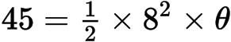
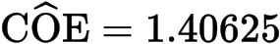 (1.41 to 3 sf) A1 N2
[2 marks]
15d. [5 marks]

Markscheme
METHOD 1
attempting to find angle EOF (M1)
e.g. 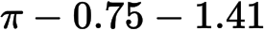
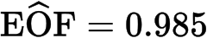 (seen anywhere) A1
evidence of choosing cosine rule (M1)
correct substitution A1
e.g.
EF 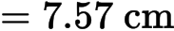A1 N3
METHOD 2
attempting to find angles that are needed (M1)
e.g. angle EOF and angle OEF
and A1
evidence of choosing sine rule (M1)
correct substitution (A1)
e.g. 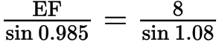
EF A1 N3
METHOD 3
attempting to find angle EOF (M1)
e.g.
(seen anywhere) A1
evidence of using half of triangle EOF (M1)
e.g. 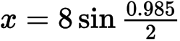
correct calculation A1
e.g. 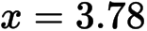
EF A1 N3
[5 marks]
16a. [4 marks]
Consider the triangle ABC, where AB =10 , BC = 7 and = 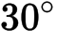 .

Markscheme
Note: accept answers given in degrees, and minutes.
evidence of choosing sine rule (M1)
e.g. 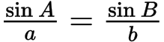
correct substitution A1
e.g. 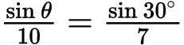 , 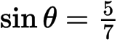
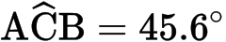 , 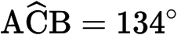A1A1 N1N1
Note: If candidates only find the acute angle in part (a), award no marks for (b).
[4 marks]
16b. [2 marks]

Markscheme
attempt to substitute their larger value into angle sum of triangle (M1)
e.g.
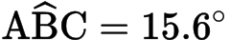A1 N2
[2 marks]
17a. [3 marks]
The following diagram shows triangle ABC .
AB = 7 cm, BC = 9 cm and 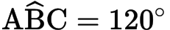 .

Markscheme
evidence of choosing cosine rule (M1)
e.g. 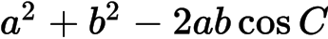
correct substitution A1
e.g. 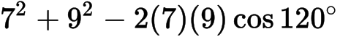
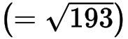A1 N2
[3 marks]
17b. [3 marks]

Markscheme
METHOD 1
evidence of choosing sine rule (M1)
e.g. 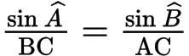
correct substitution A1
e.g. 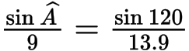
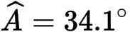A1 N2
METHOD 2
evidence of choosing cosine rule (M1)
e.g. 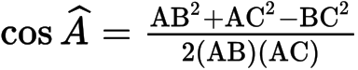
correct substitution A1
e.g. 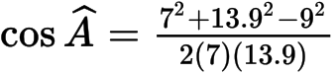
A1 N2
[3 marks]
18a. [3 marks]
There is a vertical tower TA of height 36 m at the base A of a hill. A straight path goes up the hill from A to a point U. This information is represented by the following diagram.
The path makes a 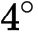 angle with the horizontal.
The point U on the path is 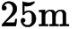 away from the base of the tower.
The top of the tower is fixed to U by a wire of length .

Markscheme
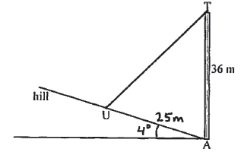 A1A1A1 N3
Note: Award A1 for labelling 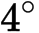 with horizontal, A1 for labelling [AU] 25 metres, A1 for drawing [TU].
[3 marks]
18b. [4 marks]

Markscheme
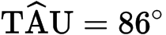(A1)
evidence of choosing cosine rule (M1)
correct substitution A1
e.g.
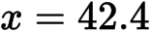A1 N3
[4 marks]
19. [7 marks]
The following diagram shows a pole BT 1.6 m tall on the roof of a vertical building.
The angle of depression from T to a point A on the horizontal ground is 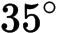 .
The angle of elevation of the top of the building from A is 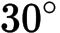 .

Markscheme
METHOD 1
appropriate approach M1
e.g. completed diagram
attempt at set up A1
e.g. correct placement of one angle
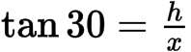 , 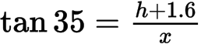A1A1
attempt to set up equation M1
e.g. isolate x
correct equation A1
e.g. 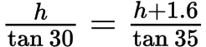
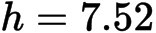A1 N3
METHOD 2
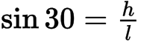A1
in triangle ATB, 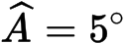 , 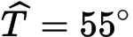A1A1
choosing sine rule M1
correct substitution
e.g. 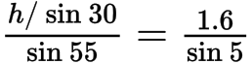A1
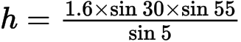A1
A1 N3
[7 marks]

Printed for British School of Beijing
© International Baccalaureate Organization 2015
International Baccalaureate® - Baccalauréat International® - Bachillerato Internacional®

